“No need for schools”: Students’ views on the present and future of digital technologies for learning.

Jacquie Tinkler
Charles Stuart University

This research captured the views of secondary school students in relation to their use of digital technologies for learning, both now and in the future. Four groups of students participated in the production of hand-drawn concept maps, followed by focus group discussions. The ways in which students considered the use of computers for the purposes of schooling was then analysed. The findings indicated that students presented a range of practical concerns, concepts of education, and affective orientations in relation to their use of digital technologies. These themes were underpinned by a range of technological deterministic views, indicating the agency students gave digital technologies to create and influence educational change. As an artefact, the computer was seen as something capable of transforming the ways schools function in the future, but also as something with relatively little pedagogical impact in the contemporary classroom.

INTRODUCTION
Despite the growth in the availability of computers for school students, there remains concern for the lack of impact of these technologies (Selwyn, 2016), and concern for their detrimental effects in the classroom such as distraction and cyber-bullying (Parsons & Adhikari, 2016). It has been suggested that a significant reason for the failure of digital technologies to make the expected impact on students’ learning is the mismatch between policy at the macro level, and the social and cultural needs of both teachers and students (Convery, 2009). Many of the needs of students in relation to technology are often assumed, such as those that are seen to constitute the ‘digital native’ (Bennet, Maton & Kervin, 2008).
The way students use digital technologies at school has been a focus of research into educational technology, however more recently research has investigated the effect of digital technologies on students’ learning outcomes, with a more critical stance emerging (Livingstone, 2012; Selwyn, 2016). Apart from some small-scale studies showing some positive effects in particular contexts, and a lot of effort from governments to provide digital technologies in schools, there has been little evidence to suggest digital technologies improve student learning outcomes (Latchem, 2014; OECD, 2011, 2013). Subsequently, a range of studies have appeared looking to understand students’ out-of-school and informal digital technology use for clues to the most effective ways to integrate digital technologies in schools (Greenhow & Lewin, 2016; Lu, Hao & Jing, 2016). Students are also negotiating their different lived experiences of digital technology use outside of school (Bennett, Maton & Kervin, 2008), with technology use occurring more often at home than at school (Fraillon, Ainley, Schulz, Friedman & Gebhardt, 2014). The relationship between home use and school use is a complex one however, and more recent research is exploring the nature and scale of these differences, suggesting that they are not as clear cut or a simple as previously thought (Bulfin & North, 2007; Salomon & Kolikant, 2016).
In this context, a growing body of research has started to explore how students are placed within the discourses of educational technology, including their needs and capabilities in relation to its use. Prominent among these has been the depiction of students as so-called ‘digital natives’, a term still used to describe contemporary students (Bennet & Corrin, 2018; Lai & Lee, 2019) who are supposed to have “…appreciably different learning styles and more of an affinity for digital learning” (Buchanan, 2011, p.70). Although many of the assumptions around young people and these terms have been debunked in a number of studies (Bennet, Maton & Kervin, 2008; Helsper & Eynon, 2010), they persist in the literature.
Given the current emphasis on digital technologies in the contemporary curriculum, it is somewhat paradoxical that students have often found using digital technologies in school rather difficult. This is not only as a result of their limited use by teachers, but particularly due to schools’ restrictions on these technologies (Selwyn & Bulfin, 2016; Stefl, Radlick & Doane, 2010). Technology out of school is generally less restricted than that within schools, creating a ‘digital disconnect’ between digital technologies use at school and out of school (Hope, 2013).
One-to-one laptop provision programs are often designed, in part, to enable students to bridge this divide between home and school (Keane & Keane, 2018; Rosen & Manny-Ikan, 2011). These programs aim to lessen the digital divide by providing access to technology, particularly for students in low-income families (Pittaluga & Rivoir, 2012). Students’ views regarding these programs show that their success can vary depending on many complex factors, including the type of device, teachers’ skill, the reliability of the technology, and expectations around the nature of schoolwork and homework (Keane & Keane, 2017; Swallow, 2015).
In this context, this paper aims to present students’ thinking and imagining about both the present and the future of digital technologies for schooling, and to determine what is the “state of the actual” (Selwyn, 2008, p.83) for these students. These findings are a part of a larger study that included various members of these students’ school communities. As recipients of netbook computers, the students in this study were at the receiving end of this one-to-one program, as well as the assumptions about their proficiency and engagement with computers. Educational policy rhetoric around the ‘technological future’ is also aimed at the presumed future needs of students, and despite the emphasis on preparing students for the technological future in such policies, students’ views of the future of digital technologies are seldom sought (Sheehy & Bucknall, 2008).

STUDY DESIGN
A qualitative methodological approach was designed to enable participants to express their ideas in a manner that was to a largely participant-led, and this approach included both hand-drawn concept maps and focus groups. Participants were drawn from two secondary schools, and consisted of twenty-three self-selected students (eleven in the Victorian school (seven female and 4 male students), and twelve in the New South Wales school (9 female, and three male students)) from years nine to eleven. Two schools were selected on the basis that they were broadly similar in terms of size, and demographics. Both were the only secondary school in their respective towns in Australia. Schools in different states were not selected as a way of directly comparing states, and it was not assumed that each single site simply stands for all sites in the state. Rather, the two sites offered opportunities for interpretive comparison of issues that were raised relating to digital technology in the two contexts.
The participants were grouped according to year level, with younger students grouped together (years nine and ten), and older students (years ten and eleven). These ages were of interest as they were the school year levels that were given the computers as a part of the one-to-one computer program. Some of these students had just received their computer less than six months before this study was undertaken (those in year nine), and others had been using their netbooks for over two years (those in year eleven).
Data Collection
The production of hand-drawn concept maps was the primary method of data collection in this study, and this was chosen as it allows participants to ‘create’ data and therefore express themselves more directly, and less interference from the researcher (Buckingham, 2009; Luttrel & Chalfen, 2010). An advantage of concept maps in this study is that they are a material artefact often used in schools, and most participants in this study were therefore familiar and relatively comfortable with their production (Wagner, 2011). In this study, they were used to encourage the elicitation of tacit knowledge such as beliefs, perceptions, ideals, values, and emotions (Kinchin, Cabot & Hay, 2008). They also allowed participants to have greater control over their thoughts and ideas than a researcher-led interview, allowing them to generate and reflect on their ideas at their own pace.
The use of concept maps also enabled the use of a graphic-elicitation approach to encourage students to further express and expand on their ideas, and it also served to provide a check of the content of the concept maps themselves (Liebenberg, 2009; O’Brien & Wheeldon, 2013). This check is important as one of the potential problems with concept maps, (as well as focus groups), is that what is produced may represent a participant’s views at a particular point in time, when doing this on a different occasion may produce different results. Therefore, the elicitation phase allows ideas to be refined or corrected as well as added to.
Data collection took place at school, with students completing two concept maps first, followed by a focus group session. Participants produced two A2-sized, hand-drawn concept maps, one of the present use of computers at school, and one of the future of computers for schooling, over the space of around 45-60 minutes. The students were asked to produce their first concept map on the topic: ‘What I think about the use of digital technologies at school’, and their second concept map on the topic ‘How do you think digital technologies might revolutionise learning and teaching in schools in the future’. These questions were designed to explore the ways in which digital technologies had affected education and school, but also as a way to consider what a digital technology-led ‘education revolution’ might look like in the future from the point of view of students.
These concept maps were then used as a starting point for the focus group discussions, with the initial question asked: “I found your perspectives and the ideas in your maps really interesting. Can you tell me about them?” This allowed participants to begin by focusing on the aspects of their maps that were of the most interest to them, allowing a discussion to develop from this starting point. For example, in the case of one group of students ‘robot teachers’ was mentioned as a simple node on some concept maps, but became the focus of some detailed discussion amongst the students in the focus group.

ANALYSIS
Each map in this study contained its own particular arrangement of textual, semiotic and compositional elements, and this combination of analytical approaches was used to analyse each student’s views as expressed in their concept maps. Data from the focus groups were then analysed along the same thematic lines as the concept maps, and this served as a partial check for the interpretation of these two data sources, and to ensure some consistency in the analysis. The overall approach to the analysis of these concept maps was influenced by Rose’s (2007) critical visual methodology framework and incorporated into this study are aspects of compositional interpretation, semiology, and intertextuality. Taken together, the diagrammatical and textual aspects of the maps formed their own meanings, and these did not arise from textual elements alone as the visual and textual worked together.
The lines and arrows of the concept maps created ‘vectors’ that joined nodes and ideas, creating a type of narrative as well as connections between ideas (Kress & van Leeuwen, 2006). Many of the concept maps contained arrows, and in some cases these created distinct narratives, with one node leading to the next, and so forth (see Figure 1). Other maps showed connections with lines rather than arrows, showing the connections between concepts, but less of a narrative. Colour was used by most students, usually for decorative purposes (in the same way colour may be used for school work), although a small number of students used colour as a semiotic device, such as the use of bright red text to indicate strength of emotion.
From this analysis process three main overarching themes were identified as ways of organizing and comparing responses. These themes are (1) practical concerns, (2) digital technologies and education purposes, and (3) affective orientations. In each case the differences that were evident in how they depicted the present and the future were also of interest.

RESULTS
Practical concerns
Unsurprisingly, students initially focused on the practical aspects of computer use, particularly given the expectation of everyday use at school and home. The limitations of the netbooks constituted a part of most students’ concept maps, and their views were largely negative. Such negativity from students was not apparent in relation to computers in general; their negativity was primarily aimed at the hardware provided. This disdain related to poor hardware specifications, numerous network updates, as well as their schools’ restricted internet access. This topic was raised by students in all focus groups, and their comments illustrate some aspects of their depictions of their day-to-day computer use:
Student 1: These ones [netbooks] are just annoying … and you can't see, because they're so small.
Student 2: They're just crappy.
Student 1: Yeah.
Student 2: They just put you off it, it's like they’ve given us something to make us hate technology.
Student 3: I hate netbooks.
(Students, younger student group, focus group 2, NSW.)
Student: The computers at home are just like 20 times faster. They're [netbooks] just ridiculously slow and out dated.
(Students, older student group, focus group 1, Victoria.)
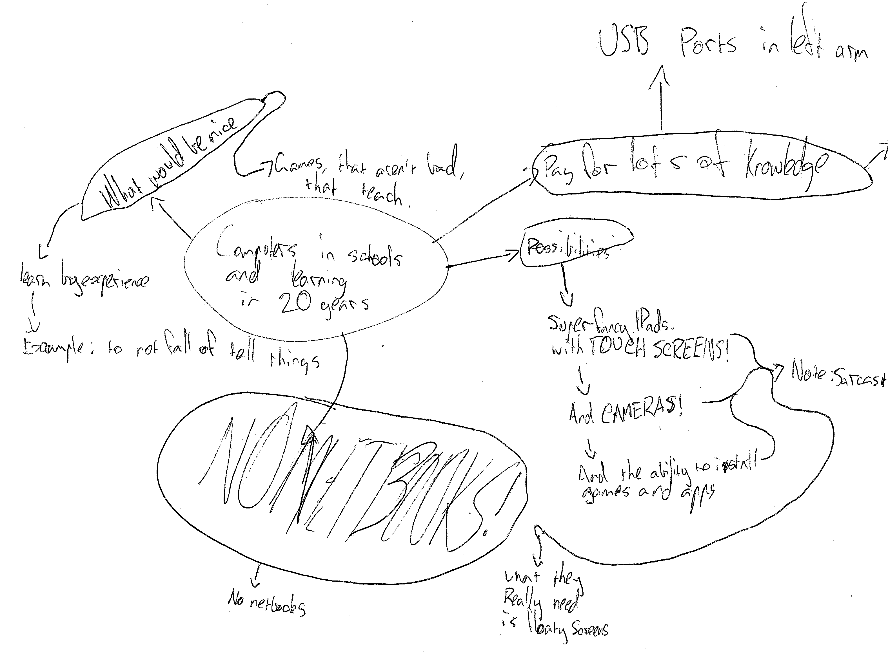
The students quoted above had access to a home computer and internet, in addition to their netbook, and it is possible that these comparisons between these computers compounded their dissatisfaction with the computers. In Figure 1. (below), this student is forthright in his displeasure of the netbooks, predicting (and perhaps demanding) in his future map that there would be “no netbooks”:
Figure 1. Younger student’s ‘future’ concept map excerpt, New South Wales school.

Internet Restrictions
In conjunction with expectations about computer hardware, students expected to effectively use the internet at school. However, the restrictions placed around internet access by their schools were one of the most common complaints made by students (see Figure 2., below):
Figure 2. Younger student, ‘present’ concept map excerpt, New South Wales.
Issues around restricted internet access were also raised in the focus group data:
Student: But… if it is something I have to do on my netbook, I’ll just do it at home, because I find it easier. I have this stigma about restrictions on the internet, and I always think I’ll get stuck with that red page [inappropriate content] coming up. But it's not inappropriate anyway, so I just do it at home on our computer, so there's no restrictions or anything.
(Students, younger student group, focus group 2, New South Wales.)
Student 1: It’s just impossible to do some assignments on this [netbook] – everything is blocked.
Student 2: Yeah, terrible.
Student 3: Yeah, that’s probably the worst thing about them.
(Students, younger student group, focus group 2, New South Wales.)
The inability of students to access internet-based resources at school meant that such work needed to be done at home, or sometimes, using their own (or borrowed), personal internet-enabled device as a workaround (Figure 3.):
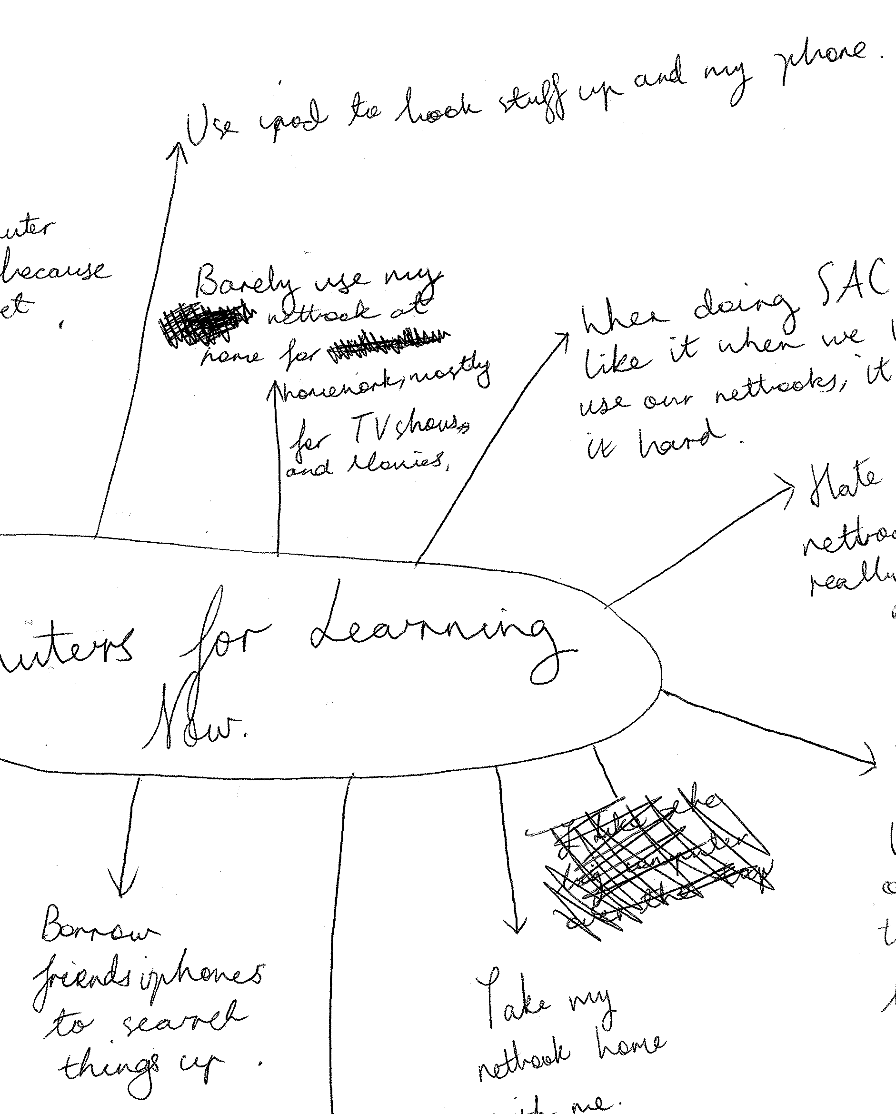
Figure 3. Older student, ‘present’ concept map excerpt, Victoria.
None of the students made an argument that all internet sites should be unblocked, but they were mostly frustrated with what they saw as overly cautious blocking of sites that meant they could not get to the sites they needed for schoolwork.
The views about the netbooks and computers were not all negative however, with some students listing their positive uses at school. The positives were also largely practical in nature, listing information retrieval and research, neatness of work, and ‘homework’ as the main benefits of computers for schoolwork. Figure 4. (below), depicts a range of practical uses and benefits:
Figure 4. Younger student, ‘present’ concept map, New South Wales.
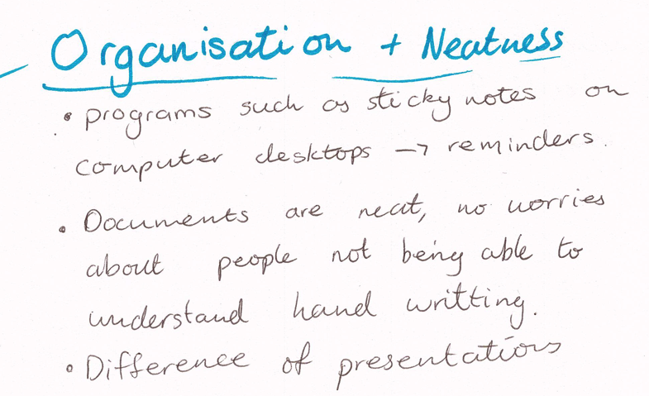
Here we see the practical nature of students’ use of computers for schoolwork – they are good for homework, they make work easy and are “very useful”. Computers also helped students organise their schoolwork, and keep it neat:
Figure 5. Older student, ‘present’ concept map excerpt, Victoria.
The ability to make schoolwork neat was a feature valued by a number of female students, as it was a way of improving the quality of their schoolwork, as they felt neatness and presentation was valued by teachers.
Perspectives on practical issues from maps of the future
The students’ concept maps of the future of computers often reiterated their current frustrations about the practical limitations of the one-to-one computers. Alongside these ideas were a range of functional and practical ideas that were proposed for the future of computers at school, and these often pointed to things that the students found frustrating in the present, focusing on improvements in existing hardware rather than anything new or futuristic.
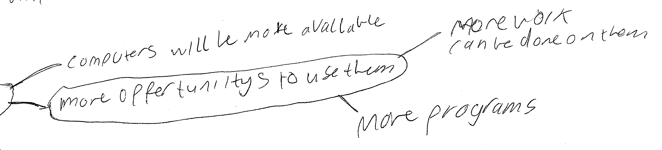
The following maps also addressed the future through the lens of the present –In Figure 6, (below), this student similarly presented a future that consisted of ‘more of the same’ with the only difference between now and the future being availability, ‘more’ use, and the capacity for more programs and more work:

Figure 6. Younger student, ‘future’ concept map excerpt, Victoria.
Overall, students did not portray a particularly ‘futuristic’ vision of the future of technology at school, they focused on better technology, and looked ahead to computers that would be both capable for their (current) intended purposes.
Concepts of education and the purpose of digital technologies
Students’ views of education and learning in relation to the use of digital technologies included the ways in which students consider their ‘digital’ schoolwork, and the role of the teacher in students’ use of digital technologies. Students often began their concept maps by listing their uses of their computers. Most of these related to schoolwork, although some included ‘non-educational’ use of their school computers such us movies, games, or hobbies. Students reported a wide range of uses for the computers including homework, assignments, organisation, email, and entertainment. Younger students included more entertainment related activities in their maps than older students. Of particular interest is that many of these school uses appeared to be computer-based versions of existing classroom practices and approaches to learning, such as using Word for essays, and PowerPoint for presentations. Older students listed more education-focused uses and software, particularly those in their final years of secondary school (Figure 7, below):
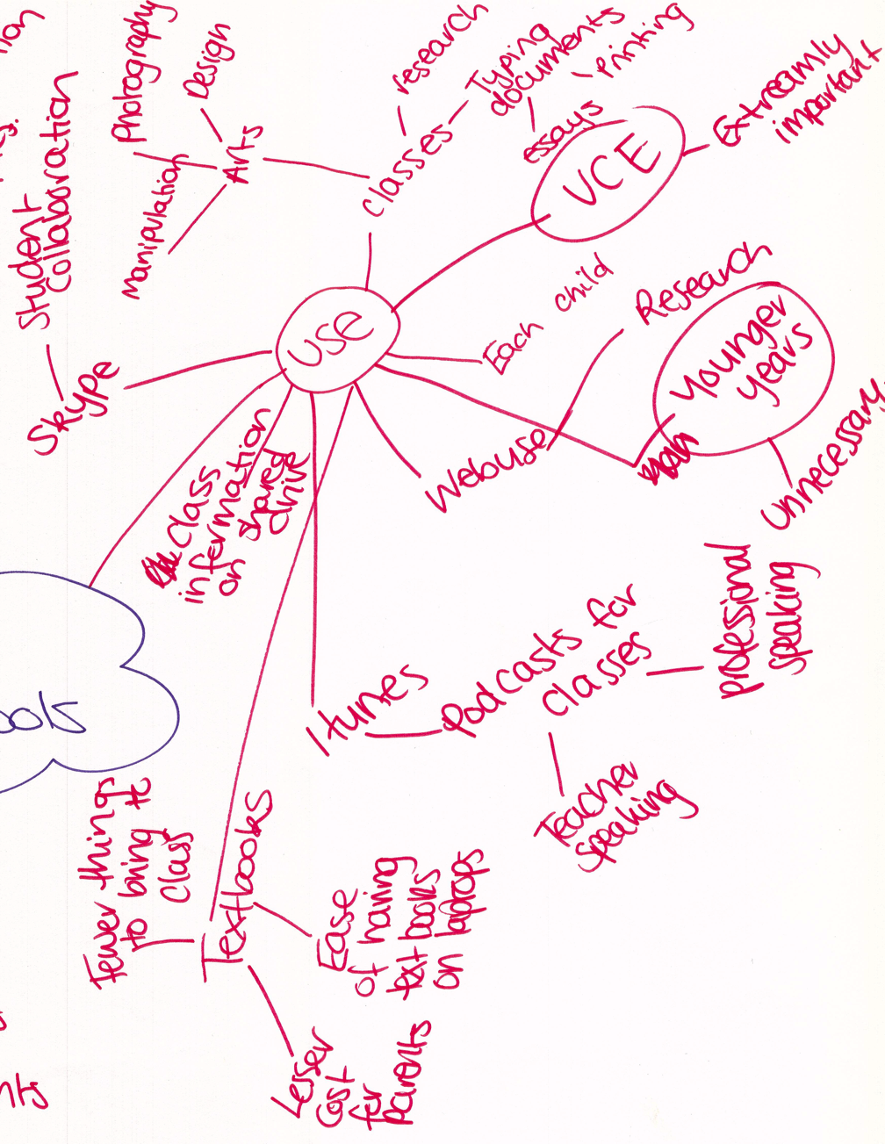
Figure 7. Older student, concept map excerpt, future, VIC.
The senior student who produced the map in Figure 7. deems the computer ‘extremely important’ for a Victorian Certificate of Education (VCE) student, depicting only educational uses, with no recreational uses shown. This student depicts the use of digital technologies as a ‘tool’, something that enables more efficient or easier production of traditional schoolwork, rather than one that enables new ways of teaching or learning. Textbooks are still needed, but in eBook form.
Digital schoolwork
Throughout the concept maps, students referred to software where it was a synonym for a particular type of use for that software. For example, some wrote ‘Word’ on their concept maps, instead of ‘writing’, ‘essays’, or ‘assignments’. Also common was ‘iTunes’ (for music), and ‘PowerPoint’ (for presentations), and this was seen in many student maps. The use of a narrow range of software such as Microsoft Office may provide some vocational advantages to students’ use of such ubiquitous software, however it also indicates a particularly narrow range of computer skills being obtained by students.
The students in this study did not often talk of ‘learning’; more often they described what they were doing, but they did describe instances where the computers had hindered their learning. Teachers were also mentioned in this context, and a number of students drew attention to the issue of teachers who did not know how to use the computers for teaching. When they were used for learning, students expected computers to be used in interesting and fun ways, and were frustrated when teachers didn’t have the skills to use them in this way:
Student 1: Like the old teachers that don’t know how to use computers.
Student 2: Oh yeah that’s true.
Student 1: Generally, a lot of the teachers don’t know how to use them.
(Students, older student group, focus group 3, NSW.)
Students had expectations not only of the hardware and internet access, but also of their teachers to be able to use the computers for learning.
The future of teachers and learning
Teachers and teaching with technology were given more attention when the concept maps and discussion turned to the future. Along with better computers, many students imagined “robot teachers” and there were also ‘holographic teachers’ represented in some maps:
Figure 8. Older student, concept map excerpt, future, NSW.
These visions of the future teacher may be extrapolated from common science fiction representations of the future and populated by humanoid robots, but they may also indicate that the robot or holographic teacher is considered the ‘next step’ in the evolution of digital technologies for schooling.
A number of similar examples showed some awareness in students of the positives and negatives on the idea of having robot teachers, but the focus groups produced more detailed descriptions of what students thought and what they wanted in their teachers:
Student 1: Robot teachers… they’ll be programmed not to get off the topic and actually provide useful information…
Student 2: …They could deal effectively with naughty children.
Student 3: With their laser eyes.
Student 1: Yeah and they wouldn’t have to suffer from – you know how sometimes teachers they, like they have their personal lives too, so they might have a bad day… like a bad home life or whatever, and they come to school angry and so they wouldn’t have these emotions that affect our learning.
(Students, older student group, focus group 1, Victoria.)
Here, ’emotionless’ technology would mean a teacher would not be affected by negative emotions that might subsequently affect the class – as well as not getting ‘off topic’. By imagining a robot as a teacher, they can pick and choose the elements of a teacher they would like, and what aspects of teachers they do not like. In spite of this however, these students still decided that they would rather not have robots as teachers:
Student 1: …there would be some [benefits].
Student 2: Like [humans] they don’t have all the answers.
Student 3: [Robots] don’t have the life experiences, like you broke your arm and they still expect you – they’re probably programmed to still expect you to do a certain amount of work or…
Student 1: Whereas a normal teacher would give you a bit slack.
Student 2: Yeah and if we have like a mental breakdown they won't be able to relate to that, they won't be able to understand what you’re going through.
(Students, older student group, focus group 1, Victoria.)

Affective orientations
One of the advantages of the use of hand drawn concept maps for data collection is the ability to see a range of affective responses from participants. Here, ‘affect’ is taken to mean emotions and their intensity (Mynard & McLoughlin, 2014). Students used a variety of compositional and semiotic devices in their drawings to express affect such as text size, colour, lines, and punctuation in their concept maps.
Computers and loss
Fear of loss in relation to the things that students valued about schooling as a result of computers at school could be interpreted from the future concept maps. Although not always using the word ‘loss’ in an explicit manner, students mentioned a range of things that they feared would be lost as a result of computers such as the loss of schools, libraries, books, teachers, and even school ‘traditions’ such as debutant balls.
These students felt the move towards virtual schools would mean the loss of face to face classes and school-based activities such as debutant balls. The following map (Figure 9, below) also highlights ‘tradition’ as a concern, but in relation to so-called ‘traditional methods’ of schooling, something this student valued:
Figure 9. Older student’s, ‘future’ concept map, Victoria.
This student raises a number of issues related to ‘traditional methods’ that they would want to see in the future in the “What I want to happen” section of the map. Through the desire for fewer computers, less cyberbullying, no computer misuse, and even better spelling, this student signals a concern for the current loss of what they consider to be ‘traditional methods’ of schooling due to the use of computers at school. On the opposing side of their map, they have a section labelled “What I believe will happen” and here we can see how they think that some of the ‘traditional methods’ will be lost. Their forecast of no schools or ‘real’ teachers, more computers, and ‘less intelligent children’ point towards a fear for the loss of the most basic of school traditions – that is the classroom and the teacher, and the inability of the computer to provide a satisfactory substitute. Students voiced concerns in relation to the idea of not having to go to school and having to complete their school work online:
Student 1: I’d hate that.
Student 2: No.
Student 3: Nah, I wouldn’t get nothing done, because like…
Student 1: It’s too distracting.
Student 3: About two weeks before school goes back after the big Christmas holidays, I’m like, I want to go back to school, I miss all my friends.
Student 2: Yeah and then you don’t meet anybody.
Student 1: Yeah, you’re like isolated, by yourself.
(Students, younger student group, focus group 2, NSW.)
A more specific concern was expressed by a number of students who were concerned for the loss of books and libraries. These artefacts of schooling might also be considered ‘traditional’ aspects of schooling, and this concern appeared in both concept maps and two of the focus groups. This prediction of loss of libraries was discussed further in the focus groups:
Student 1: Like when e-books came out I wouldn’t get a kindle…because I just wanted to…
Student 2: A what?
Student 1: A kindle – e-book thing. I had to get it to go overseas because it was just easier but it was just like I just want my paperback.
(Students, younger student group, focus group 2, NSW.)
A sense of loss appears in these excerpts from statements like: “I think that’s where it’s gone downhill”, as well as the desire for a paperback book over an eBook - an inferior artefact. For a young person to be favouring books over computers for research might be read as both a youthful nostalgia for ‘real’ books, as well as a perception that computers facilitate a shallow approach to learning. The affordances of the eBook were acknowledged by the second student: “it was just easier”, but this student still preferred their paperback book –having previously refused to have a Kindle.
Another area of concern for students was the perceived likelihood that computers would have a detrimental effect on social skills. In different maps students referred to the future of computers as one of ‘no more face to face talking’; an ‘anti-social world’, ‘more friendships ruined’, and a number referred to cyber bullying as a likely development. This fear for the loss of social skills and the increase in cyberbullying may reflect contemporary commentary (and the subsequent moral panic) about teenagers, screen-time, and the anti-social nature of the technologies young people like to use.
Frustration
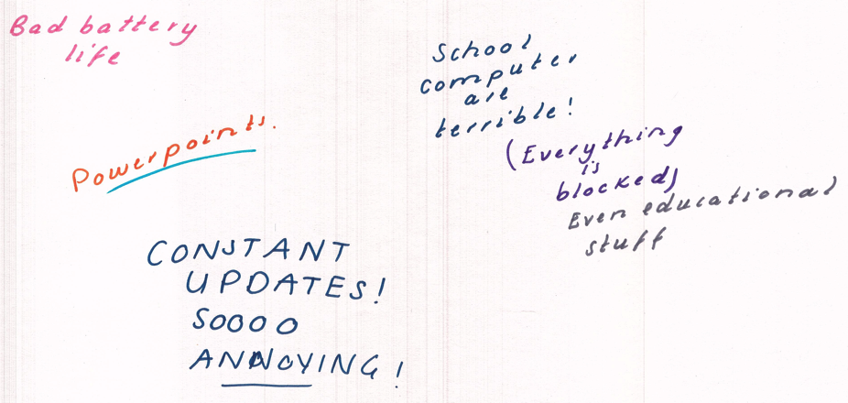
The other appearance of affect in the concept maps concerned frustration and anger, largely directed at the netbooks and their limitations. There was anger in both what they wrote, but also in the way they drew their concept maps – it manifested in a number of ways, including the use of larger writing, the use of punctuation, and other semiotic devices for emphasis. For example:
Figure 10. Younger student’s, concept map excerpt, present, New South Wales.
Although this frustration was displayed quite clearly in a number of the concept maps, this anger was not directed at computers per se – home computers were raised as computers for use for homework without such negative affect.

DISCUSSION
Students’ thinking and imagining about both the present and the future of digital technologies for schooling showed they have quite strong views about the use of such technologies for learning. Despite the stereotype of the digital native (Corrin, Bennett, & Lockyer, 2013), these students were not overly enthusiastic about the use of technology at school. Computers for schooling had a purpose which was largely to make schoolwork easier. The idea that in the future computers would in some way take away aspects of schooling that they valued also caused these students some concern. The students in this study valued their school, the material artefacts of school, as well as the relationships with each other and with teachers.

The supply of sub-par computers, as well as highly restricted internet access, caused students some stress. These students had enough experience with their home computers to know what was possible, and some viewed the poor hardware and internet filtering as undermining their attempts to use technology. The computers that were presented to students with both promise and potential, were largely resented and lay idle, and home computers were used instead. Their lack of use was not a refusal to use computers, but a refusal to use a computer that did not meet the users’ expectations. This lack of agency of their technology use at school had the appearance of non-computer use, however the home use of students in particular indicated their willingness to use computers for schoolwork.
In this context, the home became a greater extension of the classroom, with ‘digital’ schoolwork travelling between school and home with comparative ease. The ways in which the computers were used between home and school also indicates a shift in the ‘nature of schoolwork’, with the computer becoming the focus of a range of expectations and tensions around what now constitutes ‘schoolwork’. The first of these expectations was that schoolwork should now be digital. This idea was reinforced with the widespread implementation of one-to-one programs, and by ensuring all students from year nine and upwards had their own personal computer, the expectation that students would be completing schoolwork on a computer was made concrete. This expectation also included the ICT Capability Framework which also positions digital technology as one of the general capabilities in the Australian Curriculum, expecting teachers to teach and assess these capabilities as they are incorporated within students’ learning areas (ACARA, n.d.). Here, the completion of schoolwork using computers is an explicit expectation of both teachers and students, and the expectation is across the curriculum. The second expectation is that students would be using these portable computers for the completion of (digital) schoolwork at home. The netbooks were meant to be taken home for schoolwork to be completed, even though this hardware wasn’t often used in preference to the home computer.
Despite this digital turn regarding schoolwork, it was clear that for these students that the computers, when used, were being assimilated into existing classroom practices. A lot of low-level use was reported such as the use of Word for assignments and PowerPoint for presentations - the computer has provided the ability to produce ‘old-fashioned’ assignments albeit in digital form, a relatively common approach to classroom computer use (Selwyn et al., 2017). As schoolwork has become more digital, it is now less tied to physical places such as libraries and classrooms, and can easily be taken home where there are few restrictions. At school, students’ computer use was highly ordered and patterned, following the traditional organisational aspects of schooling, such as hierarchical power relationships between teachers and students, rule-making, classroom arrangements and spacio-temporal organisation of the day (Selwyn, Nemorin, Bulfin, & Johnson, 2017). It was at this point in the use of computers in school, where the aims of having computers and internet access in school (for access to information and learning opportunities) seemed to run counter to the needs of our system of schooling which (for a range of understandable reasons) requires high levels of restriction and control.
The promise of educational ‘freedom’ was one of the promised features of internet-enabled laptop computers, and by allowing students to be free of the physical confines of the classroom, it meant that education could take place at ‘any time and in any place’ (Rice, 2014). This vision, widely used in the promotion of higher education and online courses, was reflected in the responses of the students in this study to their ideas about the future of technology at school, imagining that technology used in schools today was a catalyst for the virtual or online school. Students displayed an array of affective orientations toward the possibility of such a school. As schoolwork has become more digital, it is now less tied to physical places such as libraries and classrooms.
Technological determinism
Technology is still seen by many as an autonomous force or process, and as if it has a life of its own (Apple, 1991; Nye, 2007), and this was certainly how it was spoken of by most of the students in this study. The students in this study spoke of computers in strongly technological deterministic ways, and in the process not only imbuing the computer with the agency to completely change teaching and schooling in general, but expecting it to do so. This thinking was also behind students’ views that computers will mean the ‘end’ of physical schools, handwriting, books, teachers, and libraries. Similarly, it was the computer that was the cause of distractions, laziness, and lack of homework completion.
Technological determinism also underpins the narrative of inevitability and acceptance of computers in the classroom. A deterministic stance negates the effect of the school culture to shape the technologies it has been given (Nye, 2007, p.210), and even after a technology has been built and sold, individuals still have the power to redefine the technology and use it different ways (Pinch & Bijker, 1987). It is the school ‘culture’ as well as the material limitations of the hardware that have the netbook computers often unused, or used for ‘efficiency’. As a stance, those subscribing to a technological deterministic view may take a positive or pessimistic perspective – for some, technology ‘causes’ negative outcomes, and for others, technology ‘creates’ positive change. In both cases agency is given to the artefact (Oliver, 2011).
Computer as artefact
By viewing the computer as an artefact, the computer can also be seen as a ‘cultural container’ and a technology that is a product of its environment (Harmayanthi, 2018). This view deals with social, cultural, political, and economic dynamics that come into play when introducing an artefact such as a government-supplied computer into school classrooms. Technological artefacts also have ‘interpretative flexibility’, meaning they mean different things to different people. This approach means that corporate and economic influences on the design and purchase of computers are considered, along with the political drivers of those designing policies such as the Digital Education Revolution (Rudd, Swan & Conroy, 2007). The social contexts of the school have a significant impact on the ways in which the computer is seen, used, and not used, and also accounts in part for a range of the thinking and tensions present. As an artefact in the cultural context of a school, the computer is often used to symbolise the future and progress, and is often portrayed as a symbol of ‘work’, as a way of tying school to the world of the workplace.
In addition to these representations of the computer at school were the lofty aims of educational revolution and transformation. But alongside these aims and such ‘progress’ it was also feared that computers would take teachers’ jobs, children would be taught by computerised robots, and education would generally be de-humanised and controlled by machines (Benjamin, 1988). As a contemporary artefact, the latest model computer is still routinely unveiled at technological product and policy launches as a symbol of ‘progress’ and the ‘future’ of education. The computer is a particularly political symbol for education, one that is meant to demonstrate that contemporary education is responding to an increasingly technologised world by embracing such technologies themselves (Bigum, 1997). The computer is also symbolic of how computers would enable students to become part of a “highly skilled and technologically capable workforce”, making the connection between digital technologies in school, to the future workplaces of students more explicit (Baskin & Williams, 2006, p.455).
The importance of a technologically advanced education to the economy and productivity was high on the list of the then Rudd Government’s priorities in the late 2000’s, which took a particular view of students as human capital within a global economy (Reid, 2009). Bringing digital technology to the classroom is what Selwyn (2007) describes as a ‘highly symbolic” gesture that shows a ‘strong economic imperative’ to increase the country’s competitiveness (p.34). These were reasons that did not involve educational uses of the computer as such, but ones where it was felt that the use of the computer was indeed preparing students for the future, and in particular the world of work. That the students in this study often left their computers at home, uncharged, or in their bags, also reflects the seemingly minor role that these devices played in their classrooms. The view that computers have been forced into a system that was not designed for them (or with them) is perhaps reflected in the ongoing lack of use and lack of impact more generally (Hammond, 2014; Selwyn, 2012).
As is often found, the computers were subsequently used to supplement existing practices, not enable new ones, and so the material culture of the classroom largely remained intact (Mackey, Davis, Stuart, Henderson, Rickard, Lye, & Simpson, 2015). The material tools and equipment of the classroom contribute to what is learned and how, and how a computer is produced (and by whom) similarly becomes a part of the culture of the classroom (Ensmenger, 2012). That the supplied netbooks were not used often, or schoolwork went home in preference to netbook use at school, demonstrates that in the space that is the classroom, such an artefact had to ‘earn its keep’. When they were used, they were used for what seemed to be efficiency – it is easier to write assignments, make presentations, and research for information using a computer, however these are traditional classroom tasks, with little revolutionary or transformative practices.
In this way, the computers were designed to preserve and reproduce an existing organisational power structure (Apple, 1991), where students are controlled and organised, and their access to learning materials other than school sanctioned ones is tightly restricted and controlled by the school. This meant that not only did students do much of their digital schoolwork at home, but the students with better home computers and internet also had more opportunities to do so. A large part of the dual role of the computer at school appeared to be that of a guard, shielding students from the evils of the internet (and shielding the school network from students), but at the same time restricting the extent to which it can be used as a device used for learning. The existing power structures of the school were reflected in the ways in which the computers could (and could not) be used, however, the artefact isn’t accountable for such consequences, and it is technologically deterministic to think otherwise.
CONCLUSION
This paper sought to examine the views of four groups of secondary school students about the use of digital technologies for learning at their school. In doing so, our attention has been drawn to both the practical issues surrounding the use of digital technologies at school, but also the affective orientations students expressed around the technical limitations of the supplied computers, and their concerns regarding the loss of many of the material artefacts of schooling. To some degree, the data presented here shows a clashing of aims and objectives of the netbook program with the ideas and expectations of the students receiving the computers from this program, causing a number of tensions and difficulties in relation to the intended use of these computers. The netbook computers were presented to students who had prior experience with better quality hardware and internet access, and were judged harshly as a result. For these students, a computer was something that should help them complete their schoolwork, and was not seen as a conduit to becoming a ‘knowledge worker’ or something they necessarily required for future employment.
That these young people felt concern for the loss of some of the material artefacts of school was of particular interest. Their technologically deterministic thinking led to their imagined educational landscape being one of virtual schools, no books or libraries, the loss of handwriting, and even teachers. Coming from such a perspective, these students lacked any sense of agency or control over the ways in which these computers were being used, or would be used in the future. These results point to a need for more engagement of students in the processes of planning and implementing educational technologies in schools, and a need for the student voice to be heard in terms of the type of digital technologies used, but also the ways in which they are used in their studies. The implementation of digital technologies in schools is complex and multi-layered, and it is an important part of this process to involve those who are at the receiving end of such policies and processes in such implementation.
References

Apple, M. W. (1991). The new technology. Computers in the Schools, 8(1-3), 59-82.

Baskin, C. & Williams, M. (2006). ICT integration in schools: Where are we now and what comes next? Australasian Journal of Educational Technology. 22(4), 455-473. https://ajet.org.au/index.php/AJET/article/view/1280

Benjamin, L. T. (1988). A history of teaching machines. American Psychologist, 43(9), 703.

Bennett, S., & Corrin, L. (2018). From digital natives to student experiences with technology. In Encyclopedia of Information Science and Technology, Fourth Edition (pp. 2512-2520). IGI Global.

Bennett, S., Maton, K., & Kervin, L. (2008). The ‘digital natives’ debate: A critical review of the evidence. British Journal of Educational Technology, 39(5), 775-786.

Bigum, C. (1997). Teachers and computers: in control or being controlled? Australian Journal of Education, 41(3), 247-261.

Buchanan, R. (2011). Paradox, promise and public pedagogy: Implications of the federal government's Digital Education Revolution. Australian Journal of Teacher Education (Online), 36(2), 67. https://ro.ecu.edu.au/ajte/vol36/iss2/6/

Buckingham, D. (2009). Creative visual methods in media research: possibilities, problems and proposals. Media, Culture & Society, 31(4), 633-652.

Bulfin, S. A., & North, S. M. (2007). Negotiating digital literacy practices across school and home: Case studies of young people in Australia. Language and Education, 21, 247–263.

Convery, A. (2009). The pedagogy of the impressed: how teachers become victims of technological vision. Teachers and Teaching: Theory and Practice, 15(1), 25-41.

Ensmenger, N. (2012). The digital construction of technology: Rethinking the history of computers in society. Technology and Culture, 53(4), 753-776.

Fraillon, J., Ainley, J., Schulz, W., Friedman, T., & Gebhardt, E. (2014). Students’ use of and engagement with ICT at home and school. Preparing for life in a digital age (pp. 125-166). Springer International Publishing.

Greenhow, C., & Lewin, C. (2016). Social media and education: reconceptualizing the boundaries of formal and informal learning. Learning, Media and Technology, 41(1), 6-30.

Hammond, M. (2014). Introducing ICT in schools in England: Rationale and consequences. British Journal of Educational Technology, 45(2), 191-201.

Harmayanthi, V. Y. (2018). Intercultural Assessment Through Peircean Signs of Scholars’ Digital Divide. KnE Social Sciences, 3(9), 510-521.

Helsper, E. J., & Eynon, R. (2010). Digital natives: where is the evidence? British Educational Research Journal, 36(3), 503-520.

Hope, A. (2013). The shackled school internet: Zemiological solutions to the problem of over-blocking. Learning, Media and Technology, 38(3), 270-283.

Keane, T., & Keane, W. F. (2017). Parents’ expectations, perceptions and concerns when schools implement a 1: 1 program. Education and Information Technologies, 1-18.

Kinchin, I. M., Cabot, L. B., & Hay, D. B. (2008). Using concept mapping to locate the tacit dimension of clinical expertise: Towards a theoretical framework to support critical reflection on teaching. Learning in Health and Social Care, 7(2), 93-104.

Kress, G. R., & Van Leeuwen, T. (2006). Reading images: The grammar of visual design. Psychology Press.

Latchem, C. (2014). BJET Editorial: Opening up the educational technology research agenda. British Journal of Educational Technology, 45(1), 3-11.

Lai, Y. L., & Lee, J. (2019). Learning style variation of digital natives. International Journal of Social Sciences, 4(3).

Liebenberg, L. (2009). The visual image as discussion point: Increasing validity in boundary crossing research. Qualitative Research, 9(4), 441-467.

Livingstone, S. (2012). Critical reflections on the benefits of ICT in education. Oxford Review of Education, 38(1), 9-24.

Lu, J., Hao, Q., & Jing, M. (2016). Consuming, sharing, and creating content: How young students use new social media in and outside school. Computers in Human Behavior, 64, 55-64.

Luttrell, W., & Chalfen, R. (2010). Lifting up voices of participatory visual research. Visual Studies, 25(3), 197-200.

Liebenberg, L. (2009). The visual image as discussion point: Increasing validity in boundary crossing research. Qualitative Research, 9(4), 441-467.

Mackey, J. K., Davis, N. E., Stuart, C. R., Henderson, B., Rickard, K., Lye, A., ... & Simpson, P. (2015). Leading change with digital technologies in education. https://ir.canterbury.ac.nz/bitstream/handle/10092/16293/set2015_2_017.pdf

Mynard, J., & McLoughlin, D. (2014). Affective factors in self-directed learning. Working Papers in Language Education and Research, 2(1), 27-41.

Nye, D. E. (2007). Technology matters: Questions to live with. MIT Press.

Oliver, M. (2011). Technological determinism in educational technology research: some alternative ways of thinking about the relationship between learning and technology. Journal of Computer Assisted Learning, 27(5), 373-384.

Organisation for Economic Co-operation and Development [OECD]. (2011). PISA 2009 Results: Students on Line: Digital Technologies and Performance. Paris: OECD.

Organisation for Economic Co-operation and Development [OECD]. (2013). Education Today 2013: The OECD Perspective. Paris: OECD.

Parsons, D. and Adhikari, J. (2016), “Bring your own device to secondary school: the perceptions of teachers, students and parents”, Electronic Journal of e-Learning, 14 (1), pp. 66-79.

Pinch, T. J., & Bijker, W. E. (1987). The social construction of facts and artifacts. The social construction of technological systems: New directions in the sociology and history of technology, MIT Press, Cambridge, MA

Pittaluga, L., & Rivoir, A. (2012). One laptop per child and bridging the digital divide: The case of plan CEIBAL in Uruguay. Information Technologies & International Development, 8(4), pp-145.

Reid, A. (2009). Is this a revolution? A critical analysis of the Rudd government’s national education agenda. Curriculum Perspectives, 29(3), 1–13.

Rice, M. (2014). Ethical challenges of studying online learning curriculum. Curriculum and Teaching Dialogue, 16(1/2), 131A.

Rose, G. (2007). Visual Methodologies. Sage. London.

Rosen, Y., & Manny-Ikan, E. (2011). The social promise of the Time to know program. Journal of Interactive Online Learning, 10(3).

Rudd, K., Swan, W., & Conroy, S. (2007). A digital education revolution, election 2007 policy document. Canberra: Australian Labor Party. Retrieved December 13, 2014, from: http://webarchive.nla.gov.au/gov/20120317023138/http://www.deewr.gov.au/Schooling/DigitalEducationRevolution/Pages/default.aspx

Salomon, A., & Kolikant, Y. B. D. (2016). High-school students’ perceptions of the effects of non-academic usage of ICT on their academic achievements. Computers in Human Behavior, 64, 143-151.

Selwyn, N. (2007). Plus ca change, plus c'est la meme chose - considering the probable futures of education technology. In D. W. Kritt & L. T. Winegar (Eds.), Education and Technology: Critical perspectives, possible futures (pp. 31-46). New York: Lexington Books.

Selwyn, N. (2008). From state-of-the-art to state-of-the-actual?: Introduction to a special issue. Technology, Pedagogy and Education, 17(2), 83-87.

Selwyn, N. (2012). Education in a digital world: Global perspectives on technology and education. Routledge.

Selwyn, N. (2016). Is technology good for education? John Wiley & Sons.

Selwyn, N., & Bulfin, S. (2016). Exploring school regulation of students’ technology use–rules that are made to be broken? Educational Review, 68(3), 274-290.

Selwyn, N., Nemorin, S., Bulfin, S., & Johnson, N. F. (2017). Left to their own devices: the everyday realities of one-to-one classrooms. Oxford Review of Education, 43(3), 289-310.

Sheehy, K., & Bucknall, S. (2008). How is technology seen in young people’s visions of future education systems? Learning, Media and Technology, 33(2), 101-114.

Stefl-Mabry, J., Radlick, M., & Doane, W. (2010). Can you hear me now? Student voice: High school & middle school students' perceptions of teachers, ICT and learning. International Journal of Education and Development using Information and Communication Technology, 6(4), 64.

Swallow, M. (2015). The year-two decline: Exploring the incremental experiences of a 1: 1 technology initiative. Journal of Research on Technology in Education, 47(2), 122-137.

Wagner, J. (2011). Seeing things: visual research and material culture. The Sage Handbook of Visual Research Methods, 3. Sage.

