Technology and Pedagogy Integration: A Model for meaningful technology integration
Nancy Bonfiglio-Pavisich
Catholic Education in WA

Abstract

Technology and Pedagogy Integration: A Model for meaningful learning is designed to support Catholic school educators in Western Australian schools. Catholic Education in WA (CEWA) has embarked on a process of system-wide digital transformation. The Leading Lights Program is a clearly articulated project that operates as a single digital platform for all CEWA schools and provides a paradigm for communication, collaboration, creation and personalised learning. As a digital transformation initiative, it commissions system educators to reflect upon their schools and challenges them to engage in a process that enables schools to deliver world-class learning experiences.
As a School Program Manager for Leadership (Digital Transformation) at CEWA, the researcher is proposing that whilst there is enormous pressure on schools to integrate technology, using technology for technology sake does not allow for meaningful learning to take place in the classroom. The paper seeks to explore the concepts of technology and pedagogy, but also bring to the fore what pedagogy and technology integration actually means as a concept for leaders and teachers, and how this impacts on effective teaching and learning. In doing so, the researcher makes evident the barriers that prevent effective pedagogy and technology integration from taking place and presents four models that claim to meet the need of all stakeholders in pedagogy and technology integration. She suggests that whilst all models have their strengths and weaknesses, they fail to fulfil one key requirement of education and that is meaningful learning. Through her role, the researcher believes that the TIM Matrix provides educators with a model where pedagogy and technology integration is foremost, allowing for teachers to effectively plan and implement lessons that are student focussed and reflective of various examples pedagogy and technology aligned with meaningful learning. She also suggests that the TIM Matrix provides teachers with a tool for professional learning. The literature aligned with the TIM Matrix is limited. Whilst it was designed for practitioners, it is not a research instrument. However, the researcher believes that it can support baseline data to design, plan and implement technology integration in school programmes and for teacher professional learning opportunities.

Technology and Pedagogy Integration: A vision for new learning experiences
Introduction
The digital era is upon us and whilst it provides a world of possibilities, it brings with it new ways of thinking, being and doing. In education, Fullan and Langworthy (2014, p.4) state that “the dawning of the digital age changes fundamental aspects of education”. It changes what students create, discover, learn, and how they seamlessly apply their knowledge in ways that are real and relevant with increased capacity and authentic audiences. Similarly, the Melbourne Declaration on the Educational Goals for Young Australians (2008) recognises the constant and rapid changes aligned with technology and mandates that young people be empowered with “the knowledge, skills and confidence to make technology work for them at school, at home, at work and in their communities” (Chalich, 2015, p.1). With technology included as a focus in the Australian Curriculum, educators are called upon to effectively plan and implement technology in the classroom (ACARA, 2012). With the demand for increased understanding and application of technology to support learning in the classroom, there also needs to be a framework that enables the effective integration of pedagogy and technology and promotes evidence-based meaningful learning.
More and more pressure is placed on educators to embed technology in the teaching and learning process, however, based on the researcher’s experience in Catholic Schools, it appears that teachers are working with technology in isolation. However, using technology for technology sake is not the answer (Ritzhaupt, Dawson and Cavanaugh, 2012). Researchers such as Ertmer and Ottenbriet-Leftwich (2010) highlight that technology is not being used as part of programmes or lessons to support meaningful learning in the classroom. This also appears to be the case in the primary and secondary Catholic Schools visited by the researcher in/across Western Australia.The researcher has found that technology is used in isolation to pedagogy. This paper makes a case for a pedagogy and technology integration model called the Tool Integrated Matrix (TIM), Harmes, Welsh and Winkleman (2016) that offers teachers a tool for planning, implementing and programming for meaningful learning.
First, the paper defines the concepts of pedagogy and technology individually and then explores pedagogy and technology integration as a concept. It makes the case that without consideration of density, connectivity, appropriately selected resources and the provision of holistic support for teachers, the capacity for effective technology integration is compromised (Harmes, Welsh and Winkelman, 2016). Second, the paper makes evident an educational cultural challenge. It explores the mindset of teachers and their perceptions of pedagogy and technology integration and how these may inhibit a student-centred, meaningful learning model (Hew and Brush, 2010). To this end, four models of pedagogy and their integration with technology are identified and compared, and the advantages and disadvantages for each are discussed. Equally, these models are compared to a proposed vision for new and meaningful learning, reflective of technology and pedagogy integration, via the TIM Matrix. The Matrix is designed for practitioners to effectively integrate pedagogy and technology seamlessly into classroom lessons. Whilst it is reflective of the work of Jonassen (1995) the TIM Matrix is used globally, it is not formally validated.
Technology and Pedagogy and their integration
To understand the concept aligned with technology and pedagogy integration, it is first important to define the concepts of technology and pedagogy. For instance, Beetham and Sharpe (2013, p.42) describe pedagogy as “the essential dialogue between teaching and learning”. They highlight that pedagogy informs how educators think, discuss, plan and structure activities for their students. Similarly, Waring and Evans (2014, p. 29) offer a holistic notion of pedagogy where teachers and students “promote and explore different possibilities as part of a critical and transparent dialogue”. The outcome of this is a process which empowers teachers and students to be critically aware, reflective and constructive contributors to society.
With pedagogy being the ‘how’ of teaching and learning, technology is the enabler. Rethinking pedagogy for the 21st century as “personalisation, participation and productivity”, Scott (2015, p. 2) highlights that shared pedagogy becomes a common language and is pivotal to shaping the learning culture. Complemented by the development of the new Information and Communications Technology, the capacity for effective collaboration and communication opportunities enables educators to effectively plan for teaching and learning (Scott, 2015).
Since time immemorial, technology in education has been aligned with chalkboards, pencils, manual, visual and creative arts just to name a few. In this context, technology refers to digital devices (Harmes, Welsh and Winkelman, 2016). Teaching with technology, therefore, is described by the University of Washington (2017, p. 1) as “advancements in the methods and tools used to solve problems or achieve a goal”.
Technology on its own, however, does not enhance student success in the classroom. It is the way in which technology is used and integrated as part of the teaching and learning process by teachers and students, that contributes to an impact on student performance (McNight, O’Malley, Ruzic, Horsley, Frany and Basset, 2016). This notion is shared by Ertmer and Ottenbrieit-Leftwich, (2013 p. 175) who outline that a technology integration model is one where the focus is on “the pedagogy that technology enables and supports, rather than on the technology itself”.
In this context, technology is not just about the allocation of a computer to a child but should be underpinned by real and relevant teaching and learning pedagogy in combination with well-researched assessment practices (Ritzhaupt, Dawson and Cavanaugh, 2012). The researchers highlight the teachers’ use of technology impacts its integration and student use in the classroom. Similarly, Zucker (2012) advocates that technology is used to support multiple education goals that are reflective of increased student achievement and provide high-quality education by enabling and empowering students to become creators, collaborators and effective communicators. This makes evident the need for a model that enables pedagogy and technology integration. Ertmer and Ottenbreit-Leftwich (2010) highlight that teaching will not be effective without the appropriate information technology and pedagogy to engage in meaningful learning. If consideration is not given to the barriers aligned with technology and pedagogy integration, teachers will not feel confident and or comfortable in using technology at all.
Barriers to Technology Integration
Having defined pedagogy and technology integration and its importance for meaningful learning, it is imperative to understand the potential barriers to the success of the integration process. Kim, Kim, Lee, Spector and DeMeester (2013, p.2) reinforce the work of Ertmer (1999) who identified two sets of barriers that influence technology integration in the classroom (see Table 1 below). These researchers make evident that the ‘First Order’ barriers are external by nature and pertain to the environmental capacity and readiness of technology within schools. They refer to factors such as density, connectivity and access to appropriate devices and software and the like (Ertmer, Ottenbreit-Leftwich, Saduk, Sendurur and Sendurer, 2012). Vidal and Casey (2014) also highlight the importance of a well-thought-out technology infrastructure that includes consideration for wireless coverage and cloud technologies for increased storage. This is also recommended by Schrum and Levin (2015) who provide a step by step guide in their technology audit to support teachers and leaders with planning. Ensuring that the technological readiness elements are fulfilled provides teachers with confidence that the technology will work when it is called upon. This is particularly noted in the research by Gombachika and Khangamwa (2012) where they focused on the effects of Information Technology readiness dimensions amongst Technical, Entrepreneurial and Vocational Training(TEVT) students. The data indicated that technology readiness greatly influenced the perceptions of information technology.
The ‘Second-order barriers’ are internal and are linked to teacher confidence, comfort, beliefs about student learning and the value of technology in education (Kim, Kim, Lee, Spector and DeMeester, 2013). Research findings highlight that it is these internal factors that bear great significance on whether technology is comfortably used in the classroom. Ertmer (2005) emphasises that increased confidence, comfort and attitude of teacher beliefs greatly influence effective technology integration. Similarly, Ertmer and Ottenbreit-Leftwich, (2010, p. 260) indicate that the teacher is a change agent, and in that capacity, his/her mindset is critical to teaching effectively with technology. Increased professional learning opportunities that facilitate the ‘know how’ of technology and the increased understanding and application of pedagogy are pivotal. Clark and Peterson (1986, p. 291, cited in Ertmer 2005, p. 291) highlight that “if we truly hope to increase teachers’ uses of technology, especially uses that increase student learning, we must consider how teachers’ current classroom practices are rooted in, and mediated by existing pedagogical beliefs.”
Table 1. Barriers to Pedagogy and Technology Integration
First Order Barriers to Pedagogy and Technology Integration | Second Order Barriers to Pedagogy and Technology Integration
Environmental readiness:  - Density  - Connectivity  - Devices | Teacher’s persistent beliefs about:  - Technology  - Knowledge of pedagogy  - Teacher confidence  - Teacher comfort
(Kim, Kim, Lee, Spector and DeMeester, 2013)
Ertmer, Ottenbreit-Leftwich and York (2010) make evident the importance of understanding the barriers to technology integration and the processes required to overcome these barriers. Increased confidence, an appreciation for technology as an instructional tool, organisation skills to manage technology in the classroom and a ‘can do’ attitude with appropriate professional development are some barriers to technology integration that may be overcome.
Models –Technology and Pedagogy in Action
“Pedagogy is the driver, technology is the accelerator” (Fullan, 2015, cited in Chalich 2015, p. 1). Keeping Fullan’s notion in mind, it is important to reflect upon pedagogy for the digital age. Traditional approaches that reflect rote learning and are embedded within 20thcentury learning do not support critical, creative thinking, effective collaboration, communication, character education and or citizenship as identified by Fullan and Langworthy (2014). These researchers make evident that it is these qualities that promote the new pedagogies reflective of new learning partnerships, deep learning tasks, digital tools and resources. According to Hamilton, Rosenburg and Akcaoglu (2016), there are a number of frameworks and models that have been created to support educators and research in the practice of integrating technology in teaching and learning.
Models of Pedagogy and Technology Integration
There are many and varied models that are used to describe pedagogy and technology integration (Harmes, Welsh and Winkelman, 2016). According to Kimmons (2017), these models assist teachers to think about technology in a meaningful way. Although the four chosen models of technology and pedagogy integration derive from different origins, they all share a common element, and that is the journey engaged in by teachers to effectively blend pedagogy and technology for the purposes of meeting the needs of their students. The first and second examples are reflective of teachers working individually or as part of a group. The third offers a framework that is task-focused and the four this a blend of key elements that form part of teaching and learning but is not based on levels of technology (Harmes, Welsh and Winkelman, 2016). The challenge is to adopt a model that enables the effective and efficient use of technology and pedagogy integration and meaningful learning.

Levels of Technology Implementation (LoTi) Framework
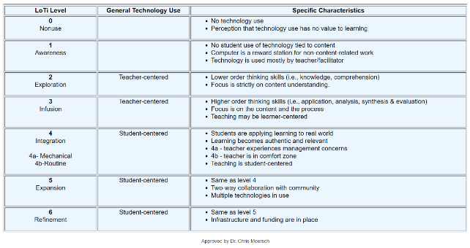
The Levels of Technology Implementation (LoTi) Framework is an empirically validated model for schools created by Moersch in 1994. Underpinned by the Concerns-Based Adoption Model that focuses on the cognitive and affective stages of change (Hall and Hord, 2015), the framework was used to measure teacher use of technology. Of focus, was how teachers modified their teaching practices to support curriculum integration (Welsh, Harmes and Winkelman, 2016). According to Davies and West (2014), the framework also offers a 21stcentury aligned emphasis on higher-order thinking, student engagement, authentic processes -all effectively embedded in instruction and appropriate assessments. Like Davies and West (2014), Judy Harris (2015) outlines that the 6-level framework (see Figure 1.) is emphatic of technology being a process and or tool that enables students to work with and resolve authentic global situations. Using the acronym H.E.A.T, (Higher-order thinking, Engaged learning, Authentic learning and Technology use), Moersch (2010) provides educators with a guide to measure the integration of these forms of learning in lessons. These are then linked to the 6 levels that are aligned with Awareness, Exploration, Infusion, Integration, Expansion. Whilst LoTi supports teacher instruction, Moersch (2010) outlines that H.E.A.T provides a measure to gauge teacher impact on student achievement.
Figure 1. LoTi Model Exemplar
Retrieved from: //www.dcet.k12.de.us/instructional/loti/lotilevelchar.shtml
Unlike Moersch (2010), Berkely-Jones (2012) in her research on LoTi and student performance, highlighted that there was not a statistical difference between the LoTi teacher level and the student mean and or math’s scores on ELA (English Language Arts) TAKS (Texas Assessment of Knowledge and Skills) for students in low Social Economic categories. Despite this, however, there were achievements noted for LoTi levels and ELA TAKS. In summary, the use of LoTi by teachers was not consistent amongst learning areas. Despite this, Moersch (2010), makes the emphasis that the updated version of LoTi reflects pedagogy at a continuum level enabling clarity for teachers moving from a teacher-centred to a learner-centred approach. This also includes movement from lower levels of cognition to higher levels, a focus on research-based classroom practice and the use of appropriate resources.
Unlike the LoTi Model, The ‘Apple Classrooms of Tomorrow’ (ACOT) framework was created as part of a research project undertaken by Apple. The project made evident the process by which teachers were able to engage in pedagogy and technology using the ACOT Stages of Instructional Evolution (Sandholtz, Ringstaff and Dwyer, 1997). Each of these stages known as Entry, Adoption, Adaptation, Appropriation and Invention were identified as levels for purposeful changes. As teachers moved to each level, they developed the confidence to expand their teaching and learning capacity and adopted processes that were active and creative by nature (Sandholtz, Ringstaff and Dwyer, 1997). (see Figure 2.) Similarly, Ringstaff, Yocam and Marsh (1996) highlight that educators reflected on their traditional teaching processes and realised their energies would be best served using constructivist teaching strategies. With increased exposure and opportunity, educators became learners and used technology with greater frequency and linked planning in the classroom.
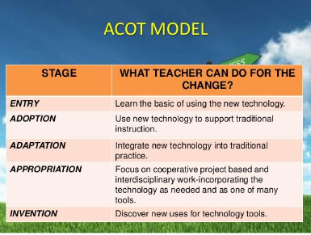

Figure 2: ACOT Model by Apple Classrooms of Tomorrow
Retrieved from https://larrycuban.wordpress.com/2016/09/11/stages-of-technology-integration-in-classrooms-part-3/
The ACOT project was successful as part of a training process, but Ringstaff, Yocam and Marsh (1996) make evident that there were challenges that affected the successful implementation of the project in school communities. These included: some teachers were “unable to change their instructional philosophy” (p.13) and those who had limited technology knowledge, skills and understandings were not able to bring the project to the classroom.
Similarly, technical challenges with readiness and unsupportive principals, inhibited the growth of the project in schools.
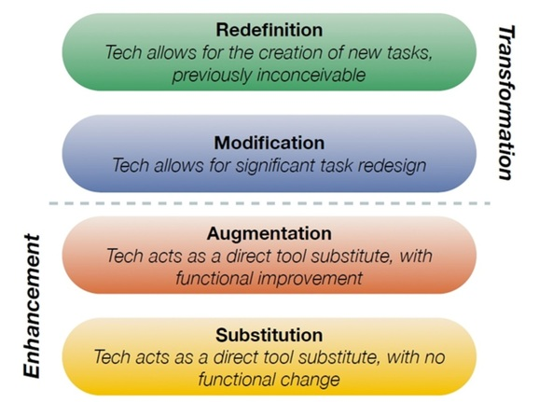
Figure 3: SAMR Model by Dr Ruben Puentedura
Retrieved from http://www.hippasus.com/rrpweblog/
Another framework that promotes technology and pedagogy integration is the SAMR Model (Substitution, Augmentation, Modification, Redefinition). (View Figure 3.) Created by Dr Puentedura, the SAMR Model provides a lens through a blended approach to technology integration and focuses on four elements of technology integration in the classroom (Gorman n.d.). According to Puentedura (2006), the SAMR model enables teachers to think about the use of technology and the way in which this can drive the teaching and learning process to new levels. The first two stages (Substitution and Augmentation) may be used for traditional task-focused activities. Substitution is a stage that encompasses the replacement of old technology with new technology. Puentedura (2014) cited in Hamilton, Rosenburg and Akcaoglu (2016, p. 4) indicates that this change does not provide “functional change”. At the Augmentation stage, however, “the tool is substituted with functional improvement” that enables greater learning (Hunter 2015, p.49). The last two stages (Modification and Redefinition) enable students to partake in activities that go beyond the physical school buildings. Modification enables technology to be used to redesign tasks and Redefinition looks at the “creation of tasks that were once not deemed possible” (Hunter 2015, p. 49). At the latter stages, the learning process is re-defined, and tasks are both rich by design and reflective of what cannot be done without technology (Welsh, Harmes and Winkelman, 2011).
The challenge, as indicated by Hamilton, Rosenburg and Akcaoglu (2016, p. 4), is that there is no theoretical explanation of the model in peer-reviewed literature. They also argue that SAMR offers no acknowledgement of context and consequently it does not recognise student needs, teacher knowledge and or technology infrastructure. Additionally, its rigid taxonomy structure does little to support educators and only functions to describe key practices via a four value-based level framework. Together with a “product overprocess” approach, where the emphasis is on technology to support process as opposed to meeting specific student need, the levels become the focus of SAMR and not “the instructional objectives and achieving learning outcomes” (Reiser and Dempsey, 2012, p. 10).
The TPACK (Technological Pedagogical Content Knowledge) Model (Koehler and Mishra, 2005, 2009) is based on the work of Shulman (1986), known as PCK. This model as presented in Figure 4. below offers a process by which technology can be linked to content knowledge via three aspects of teaching and learning: “content (subject matter to be taught), pedagogy (knowledge of teaching and learning) and technology (seamless embedding of technology in daily operations)”(Harris, Mishra and Koehler, 2009, p. 397).According to Hunter (2015), the TPACK model enables educators to truly reflect upon the teaching and learning process. In doing so, it emphasises the relationship between constantly evolving technology and teacher confidence and comfort, along with the skills required for its effective application in the classroom. Whilst the TPACK has advantages, Adam (2017) highlights that the TPACK fails to explore the links between technology, pedagogy and culture.
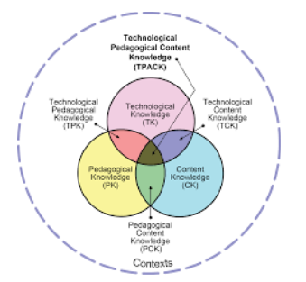

Figure 4. TPACK Framework and Is Knowledge components (Adapted from Koehler & Mishra, 2008)
Ertmer (2013, p. 104) outlines that the “TPACK model takes the concept of technology integration and packages it as a framework that is much too big” and as a result is very complex by nature. Similarly, Archambault and Crippen (2009, p. 108) argue that the “TPACK is built on a fuzzy base” and has boundaries that lack clarity. Ertmer (2013, p. 115) suggests that researchers such as Harris et al. (2009) and Polly et al. (2010) indicate that technology integration occurs when it is able to “synthesise knowledge about technology, pedagogy and content” (p. 115).
The four models for pedagogy and technology integration presented in this paper are examples of a constructivist approach to learning, that is, “learners are active knowledge constructors rather than passive information receivers” (Jonassen, 1991 cited in Wang, 2008, p. 413). They all provide educators and students with the opportunity to engage in the process of learning that is “interactive’ focused and reflective of interaction that includes: “learner-content, learner-people and learner-interface” (Wang, 2008, p. 414). The LoTi model offers levels of technology learning that range from teacher centred through refinement to student centred but does not provide a lesson guide or indicate how meaningful learning can be achieved. The ACOT model, however, is designed to enable teachers and learners to construct meaning but falls short of implementation guides to ensure its success in the classroom. Similarly, Shaw (2015) identifies that whilst the SAMR model is simple by nature, it “focuses on how a learning activity is changed while saying nothing about how to determine the value of that change” (Shaw, 2015, p. 2). Alternatively, the TPACK model enables technology, pedagogy and content knowledge to be considered in the teaching and learning process but the crossovers between the three areas cause confusion (Archambault and Crippen, 2009). Given that all four models offer guidance to the pedagogy and integration process, the challenge with all of them is the provision of a support model to assist teachers in overcoming barriers.
Vision for new learning experiences
Merrill, Elen and Bishop (2014, p. 15) highlight “that learning theories and technology are empty concepts when not connected to actors, such as instructional designers, teachers, and learners.” Like Merrill, Elen and Bishop (2014), Ertmer and Ottenbrieht-Leftwich (2010) make evident that in understanding the technology requirements for teaching and learning in the 21stcentury, educators need to be supported with the knowledge, skills and understandings to engage their pupils in the process of learning that is student centred and reflective of deep and meaningful learning opportunities (Fullan, 2014). In doing so, Lawless and Pellegrino, (2007, p. 581, cited in Ertmer and Ottenbrieht-Leftwich, 2013) highlight that “technology can make it quicker or easier to teach the same things in routine ways,” and it also makes it possible to “adopt new and arguably better approaches to instruction and/or change the content or context of learning, instruction, and assessment”.
Having compared four models which allow for pedagogy and technology integration, the TIM model (Harmes, Welsh and Winkelman, 2016) is proposed as a new vision for learning experiences. Relaunched in February 2011, the TIM provides a model that supports teachers and students to integrate pedagogy and technology with the purpose of engaging in meaningful learning whilst simultaneously offering what the particular learning environment may look like (Welsh, Harmes, and Winkelman, 2011).
The TIM Framework Model was created by the Florida Centre for Instructional Technology and provides a model of pedagogy and technology integration that links into lesson design. The resource is referred to as a matrix that consists of 25 cells. The cells are made up of five levels of technology integration that begin at an entry level (teacher centred) and extend through to a transformation level (student centred) and link into five characteristics of meaningful learning. These characteristics of meaningful learning include: Active, Constructive, Authentic, Collaborative and Goal-directed. Combined, the cells provide a framework to support educators in effectively planning and implementing lessons that are student-focused and reflective of a process of technology and pedagogy integration that enables meaningful learning (Welsh, Harmes, and Winkelman, 2011). The TIM is identified in the following figure.
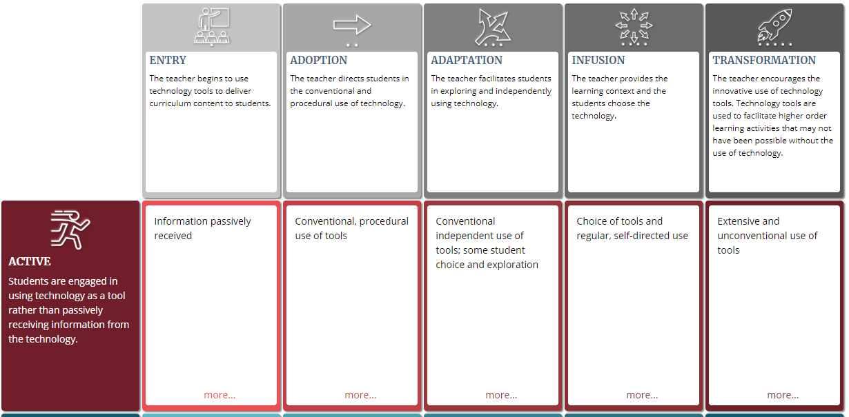
Figure 5. The Technology Integrated Matrix
Retrieved from https://fcit.usf.edu/matrix/
Unlike the LoTi, ACOT, SAMR and TPACK models, the TIM places its emphasis on “the pedagogy with which technology is incorporated” in the classroom lesson (Welsh, Harmes, and Winkelman, 2011, p. 140). The model does not focus specifically on a teacher or task but instead offers a continuum of pedagogical approaches with students and teachers empowered to select tools to fulfil teaching and learning requirements. These tools reflect the levels at which teachers are at, i.e. Entry, Adoption, Adaptation, Infusion and Transformation and allow for their progression with the development of confidence and comfort with technology. They also enable lessons to move from teacher centred to student centred and thus empower students to make the choices they need to complete their work in a seamless manner (Welsh, Harmes, and Winkelman, 2011). The table below summarises the key components of each of the Pedagogy and Technology Integration Models.

Table 2. Summary of Pedagogy and Technology Integration Models
LoTi | ACOT | SAMR | TPACK | TIM
Created by Dr Christopher Moersch | Apple Research Project | Created by Dr Puentedura | Created by Koehler and Mishra | Created by the Florida Centre for Instructional Technology
1995 | 1995/8 | 1996 | 2005 | 2011
LoTi Scale measures  authentic classroom use of technology via levels:  - Non-use  - Awareness  - Exploration  - Infusion  - Integration  - Expansion  - Refinement | The model has 5 distinct levels of technology  integration:  - Entry  - Adoption  - Adaption  - Appropriation | Model for progressing  through teaching and learning with  technology:  - Substitution  - Augmentation  - Modification  - Redefinition | Model for reflection on teaching and  learning that  embeds the three levels of knowledge:  - Content  knowledge  - Pedagogy knowledge  - Technology  knowledge | Model of characteristics of meaningful learning that are linked with levels  of technology characteristics of  meaningful learning:  - Active  - Collaborative  - Constructive  - Authentic  - Goal Oriented  Levels of technology:  - Entry,  - Adoption,  - Adaptation,  - Infusion and  - Transformation

Whilst the TIM does not provide a focused approach like the TPACK; it offers a framework that enables educators to align their professional development opportunities via various approaches based on their context, curriculum, resources available and most importantly, their needs and those of their students (Welsh, Harmes, and Winkelman, 2011). Given its common language and simplistic matrix-like structure, the TIM can also be used to build teacher capacity by assisting teachers to set goals and to engage in reflective practice. In doing so, the focus of TIM is a process of technology integration where pedagogy is front and centre so that students do not just learn about content but develop and apply real-world skills as part of their learning.
Conclusion
With the requirement of the Australian Curriculum mandating technology in the classroom and the need to prepare students for the 21st century, teachers are commissioned to effectively plan for technology and pedagogy integration. This paper is based on the assumption that teachers need the knowledge, skills and understandings to be able to do this effectively. The TIM Matrix serves the needs of the 21st-century learner by providing a model for teachers to use that effectively integrates pedagogy and technology in the classroom. Various models have been presented and whilst they all reflect a constructivist theoretical approach their shortfall is in the capacity to support meaningful learning in lessons. The TIM Matrix is a tool specifically designed for practitioners and offers a model for pedagogy and technology integration that not only includes levels of technology but consists of characteristics proven to facilitate meaningful learning. Together, the levels of technology and the characteristics of meaningful learning assist teachers to plan lessons that are student centred and reflective of 21st-century learning pedagogies that support skill development such as communication, collaboration, creativity and critical thinking. Given that there is limited research with the TIM Matrix, there is a need to collect evidence-based data about how the TIM Matrix is used in schools and how it informs best practice in teaching and learning. This will also provide opportunities to inform whole school planning and professional development programs for teachers.

References
Acara (Australian Curriculum, Assessment and Reporting Authority) (2012). https:www.acara.edu.au. Date Accessed 10 December 2017.

Archambault, L., & Crippen, K. (2009). Examining TPACK among K-12 Online Distance Educators in the United States. Contemporary Issues in Technology and Teacher Education, 9, 71-88. Retrieved from http//www:citejournal.org/vol9/iss1/general/article2.cfm

Beetham, H., & Sharpe, R. (2013). Rethinking pedagogy for a digital age: Designing for 21st century learning. (2nd ed) New York: Taylor & Francis.

Berkeley-Jones, C., S. (2012). A study of the relationship between levels of technology implementation (LoTi) and student performance on Texas assessment of knowledge and Skills (TAKS) scores. Doctoral dissertation, Texas A&M University.

Chalich, A. (2015). Integrating technology with classroom pedagogy –accelerate student learning. Retrieved from https://www.educationtechnologysolutions.com.au/2015/08/integrating-technology-with-classroom-pedagogy-accelerate-student-learning. (Accessed 17 December 2017)

Davies, R. S., & West, R.E. (2014). Technology integration in schools. In J.M. Spector, M.D. Merrill, J. Elen, & M.J. Bishop (Eds), Handbook of Research on Educational Communications and Technology 841-853 New York: NY: Springer.doi:10.10007/978-14614-3185-5_68

Ertmer, P.A. (1999). Addressing first-and second-order barriers to change: strategies for technology integration. Educational Journal Research and Development 47(4), 47-61

Ertmer, P.A. (2005). Teacher pedagogical beliefs: the final frontier in our quest for technology integration? Educational Technology Research and Development, 53(4), 25-39

Ertmer, P.A. & Ottenbreit-Leftwich, A., (2010). Teacher technology change: how knowledge, confidence, beliefs and culture intersect. Journal of Research on Technology in Education, 42(3), 255-284

Ertmer, P.A. & Ottenbreit-Leftwich, A., (2013). Removing obstacles to the pedagogical changes required by Jonassen’s vision of authentic technology-enabled learning. Journal of Computers and Education, 64,175-182

Ertmer, P.A. Ottenbreit-Leftwich, A., Sadik, O., Sendurur, E & Sendurer, P., (2012). Teacher beliefs and technology integration practices: examining the alignment between espoused and enacted beliefs. Journal Teachers’ pedagogical beliefs: Definition and operationalisation-connections to knowledge and performance-development and change. 149-169.

Fullan, M., Scott, G. (2014). New pedagogies for deep learning white paper: Education plus the world will be led by people you can count on, including you!. Washington: Collaborative Impact SPC.

Fullan, M., & Langworthy, M. (2014). A Rich Seam. How new pedagogies find deep meaning? London: Pearson.

Gomachika, H, S, H., & Khangamwa, G. (2012). ICT readiness and acceptance amongst TEVT students in University of Malawi, Campus-Wide Information Systems, Vol 30 (1) 35-43.

Gorman, M. (nd) The SAMR model of technology integration article. Retrieved from http://21centuryedtech.wordpress.com.https://sacsteacher.weebly.com/uploads/3/1/9/1/31918433/the_samr_model_of_technology_integration_article.pdf (Date accessed: 10 December 2017).

Hamilton, E., J. M., & Akcaoglu, M. (2016). The Substitution Augmentation Modification Redefinition (SAMR) Model: A critical review and suggestions for its use. Tech Trends: Linking Research and Practice to Improve Learning, 60(5) 433-441http://www.researchgate.net/publication/303600132

Harmes, J.C., Welsh, J.L., & Winkleman, R.J. (2016). A framework for defining and evaluating technology integration in the instruction of real-world skills. In S. Ferrara, Y. Rosen, & M. Tager (Eds.), Handbook of Research on Technology Tools for Real World Skill Development.137-162.

Hershey, PA: IGI GlobalHarris, J., Mishra, P., & Koehler, M. (2009). Teachers’ technological pedagogical content knowledge and learning activity types. Curriculum-based Technology Integration Reframed. 393-416. Retrieved from https://doi.org/10.1080/15391523.2009.10782536

Harris, J. (2005). Our agenda for technology integration: It's time to choose. Contemporary Issues in Technology and Teacher Education, 5(2), 116-122

Hew, K, F., & Brush, T. (2010). Integrating technology into k-12 teaching and learning: current knowledge gaps and recommendations for future research. Educational Technology, Research and Development 55(3) 223-252

Hall, G, E., & Hord, S, M. (2015). Implementing Change: patterns, principles and potholes. In Leadership in Mathematics Education. Retrieved from www.mathleadership.org/docs/ coaching/Pl-B-HALL.pdf
Hunter, J. (2015). Technology integration and high possibility classrooms. Building from TPack. London: Taylor & Francis

Kim, C.M., Kim, M.k., Lee, C., Spector, M. J., & D, K. (2013). Teacher beliefs and technology integration. Teaching and Teacher Education: An International Journal of Research and Studies 29, 76-85

Kimmons, R. (2017). K-12 technology frameworks. Adapted from R. Kimmons (2016). K-12 technology integration. Press Books.

Koehler, M.J., & Mishra, P. (2009). What is technological pedagogical content knowledge? Contemporary Issues in Technology and Teacher Education, 9(1), 60-70.

Moersch, C. (2010). LoTi Turns up the H.E.A.T. Learning and Leading with Technology, 37 (5), 20-23

McKnight, K., O’Malley, K., Ruzic, R., & Horsley, M.k. (2016). Teaching in a Digital Age: How Educators Use Technology to Improve Student Learning. In Journal of Research on Technology in Education. 48(3). New York: Taylor and Francis

Melbourne Declaration on the Educational Goals for Young Australians (2008). Melbourne: Ministerial Council on Education, Employment, Training and Youth Affairs

Polly, D., Mims, C., Shepherd, C & Inan, F. (2010). Evidence of impact: Transforming teacher education with preparing tomorrow’s teachers to teach with technology (pT3) grants. Retrieved from https://doi.org/10.1016/j.tate.2009.10.024

Puentedura, R., R. (2006). Transformation, technology and education. Retrieved from http://hippasus.com/resources/tte/

Reiser, R.A., & Dempsey, J.V. (2012). Trends and issues in instructional design and technology. (3rd ed.). Boston, Massachusetts: Pearson.

Ringstaff, C., Yocam, K., & Marsh, J. (1996). Integrating technology into classroom instruction: An assessment of the impact of the ACOT Teacher Development Centre Project. Apple Classrooms of Tomorrow.

Ritzhaupt, A.D., Dawson, K., & Cavanaugh, C. (2012) An investigation of factors influencing student use of technology in K-12 classrooms using path analysis. Journal of Educational Computing Research, 46(3) 229-254. Baywood Publishing.

Sandholtz, J.H., Ringstaff, C., & Dwyer, D., C. (1997). Teaching with technology: Creating student-centred classrooms. New York: Teachers College Press.

Schrum, L,R., & Levin, B. (2015). Leading 21st Century Schools: Harnessing technology for engagement and achievement. (2ed). USA: Corwin

Scott, C., (2015). The Futures of learning 3: What kind of pedagogies for the 21st century? In Education Research and Foresight: Working Papers UNESCO Retrieved from http:WWW.unesco.org/images/0024/002431/243126e
Sharratt, L. (1999). Technology implementation: lessons for school and district leaders. Orbit (30)1, 36-39.

Shaw, T. (2015).The problem with the SAMR model. eSchool News. Retrieved from https://www.eschoolnews.com/2015/04/27/samr-model-problems-842/2/ Date Accessed 17 December 2017Teaching with Technology. (2017). Retrieved from www.washington.edu/teaching/teaching-resources/engaging-students-in-learning/teaching-with-technology-2/

Vidal, D., & Cassey, (2014). Next Practices. An executive guide for education decision makers. UK: R & L Education

Wang, Q. (2008). A generic model for guiding the integration of ICT into teaching and learning. Innovations in Education and Teaching International. 45(1), 411-419

Waring, M., & and Evans, C. (2014)., Understanding Pedagogy: developing a critical approach to teaching and learning. New York: Taylor & Francis

Welsh, J., Harmes, J.C., & Winkelman, R. (2011). Florida’s Technology Integration Matrix. Principal Leadership, 12(2), 69-71.

Zucker, A., (2012). Using digital tools to help transform schools. Retrieved from: http://www.advanced.org/source/using-digital-tools-help-transform-schools.

