Pre-Service Teachers Designing and Constructing ‘Good Digital Games’

Corbett Artym, Mike Carbonaro and Patricia Boechler
University of Alberta

Abstract

There is a growing interest in the application of digital games to enhance learning across many educational levels. This paper investigates pre-service teachers’ ability to operationalize the learning principles that are considered part of a good digital game (Gee, 2007) by designing digital games in Scratch. Forty pre-service teachers, enrolled in an optional educational technology course, designed and constructed their own digital games in an authentic learning context. The course was structured to prepare pre-service teachers to use game design and construction in their future pedagogical practice. These pre-service teachers had various levels of game-playing experience, but little-to-no previous game-design/building experience. To evaluate the digital games, we created the Game Design Assessment Survey, which determined the degree to which a core set of learning principles, identified from the literature, were present in the digital games constructed by the pre-service teachers. Results suggested that pre-service teachers were generally unaware of the learning principles that should be included in the design of a good digital game, but were familiar with quality principles of interface usability. In addition, no relationship was found between the amount of time pre-service teachers played digital games and their ability to design and construct a good game.

Keywords

Game design, digital games, pre-service teachers, Game Design Assessment Survey, Scratch

Introduction

An ongoing challenge for schools of education is to adequately prepare pre-service teachers to integrate various forms of technology to meet the needs of 21st century learners (Cydis, 2015). Increasingly, it has been suggested that the use of digital games can support and enrich learning at different educational levels (Brown, 2014; Clark, Tanner-Smith, & Killingsworth, 2015; Gee, 2013; Whitton, 2014). This is timely given that recent reports indicate that 90% of Canadian, 84% of Australian, and 97% of American teens play digital games (Brand & Todhunter, 2015; ESA, 2012; Lenhart et al., 2008). As a result, it would be practical for pre-service teacher to incorporate new and innovative ways of including digital games into their future instructional practice (Schrader, Archambault & Oh-Young, 2011).

Overall the research on digital games in education has primarily centred on students as players & users of digital games and not as designers & builders of games (Author, 2008). Prensky (2008) advocated that students should be placed in the role of designers and constructors of digital games to enhance school curriculum and student engagement. There is increasing evidence indicating that learner outcomes can improve when students are designers and builders of digital games and not just players (Author, 2010; Denner, Werner, & Ortiz, 2011; Good, 2011; Robertson & Howells, 2008; Ke, 2014; Vos, van der Meijden, & Denessen, 2011).

Li (2013) presented evidence that future teachers need to acquire hands-on digital game design skills if they are to effectively integrate games into classroom instruction. Koehler and Mishra (2005) argued that teacher preparation programs need to go well beyond training pre-service teachers as users of software tools (e.g., digital games) in classrooms and instead should focus more directly on a learning-by-design approach to technology integration for teacher education: “By participating in design, teachers build something that is sensitive to the subject matter (instead of learning the technology in general) and the specific instructional goals (instead of general ones)” (p. 95).

One effective way for pre-service teachers to understand, learn, and participate in the learning design approach is to immerse them in an authentic technology-rich learning environment that models the learning situation their students would encounter (Herrington, Reeves, Oliver, 2014; Latham & Carr, 2012). In the context of digital game design and construction, this would include having pre-service teachers experience a learning environment in the role of a game designer (Hsu & Chiou, 2014), and having them understand how they, as future teachers, can make use of digital game construction to enrich their own pedagogical practice in the teaching of subject area content (Ke, 2104).

If teachers intend to incorporate digital game design and construction to support and enhance their pedagogical practice, they should be aware of what constitutes the design of a good digital game. Gee (2007) argues that good digital games incorporate powerful learning principles that organize learning in deep and effective ways and that these principles “could well be used in schools to get students to learn things like science” (p. 2). The current project investigates whether pre-service teachers, as designers and builders of a digital game, incorporate the principles of learning they may have unconsciously encountered as game players. We take the approach that good digital games are designed and built on good learning principles that have been substantiated by research work in cognitive science (Gee, 2007). Our motivation for this project work was based on observations, as instructors, that our learners’ game-playing experience appeared to have a tenuous relationship to their game building experience with respect to what constitutes designing and constructing a good digital game.

In this project, pre-service teachers were asked to design and construct a digital game of their choice as part of an optional course on educational technology that was operationalized in an authentic pedagogical environment. The course is structured such that pre-service teachers: a) learn about game design and construction as it relates to various educational learning theories (e.g., constructivism, constructionism, social constructivism); b) are taught how primary and secondary students can better learn and understand subject area content (e.g. social studies, math, science, etc.) through the process of game design and game construction; and c) are the designers and builders of their own digital games. Our exploratory question is: To what degree can pre-service teachers, who have various amounts of game playing experiences and little to no previous game design/building experience, design and build a ‘good digital game’? Here the construct of a ‘good digital game’ was operationalized through an extensive review of the literature, which includes a focus on the work of Gee (2003; 2005; 2006; 2013; 2014) who identified ways that digital games can engage, motivate, and incorporate good learning principles. To assess the games, we developed an instrument, the Game Design Assessment Survey (GDAS). What follows is a description and rationale used in the development of the GDAS, the findings from the initial application of the GDAS to a set of games constructed by a sample of pre-service teachers, and a discussion of the study findings for pre-service teachers intending to use game design and construction to enhance the learning of content.

Rationale of the Game Design Assessment Survey (GDAS)

The literature review identified six major categories that were organized around shared concepts and operationalized in criteria scales: Problem Solving Opportunities, Customization of Player Experience, Game Atmosphere, Player Interaction, Player Motivation, and Interface Usability (see Appendix). Each category is composed of a set of criteria that indicates a range. The overall maximum score on the GDAS is 32 points. Two researchers pilot-tested the GDAS on a subset of games that were not included in the study; experts in assessment, educational psychology, and digital gaming were consulted, and the instrument underwent numerous revisions. The following sections outline the rationale and essential criteria that was derived from a review of the literature to instantiate the GDAS categories and scales.

Problem Solving Opportunities
Problem Solving Opportunities examines the challenges that the designer has created for the player to engage with.

Game contains cognitive objectives

Games should be an interactive experience for the player and provide challenging tasks (Dickey, 2005; Gee, 2005). Overall, cognitive objectives require effort to solve and provide opportunities for additional cognitive processing (Rice, 2007). We have chosen to split this section of the survey up into higher- and lower-end problems, as per Bloom’s (1956) Taxonomy.

Forgiveness

One learning principle that most digital games incorporate is a low cost of failure (Groff, Howells, & Cranmer, 2010; Klopfer, Osterweil, & Salen, 2009; Koster, 2005) which provides the opportunity to build self-efficacy (Bandura, 1994), and which is typically implemented in the form of lives, checkpoints, or continues. If players do not need to restart the game from the beginning, and are able to retry the portion where they made an error, they can focus on the area where they had a problem while not being forced to replay or redo content leading up to it. Dickey (2005) describes this as the protection from adverse consequences on their initial failures. Gee (2013) also expresses that players may be more willing to make errors and explore, if the consequences of failure are low.

Challenge incrementally increases as the game progresses

Well-ordered, pleasantly frustrating problems should prepare players for challenges that they encounter later in the game: early challenges set up later success (Gee, 2013; Mayer, 2011; e.g., antagonists or cognitive objectives become more difficult as the game progresses). Vygotsky (1978) stressed the instructional approach of scaffolding to support concept learning. In the context of digital games, this approach would help the player learn new skills, achieve mastery of the skills, and incrementally build a skill set throughout the game.

Customization of Player Experience
A good game incorporates either a) the opportunity for the player to customize play to their preference, or b) allows for a diverse range of playing and learning styles. When we apply this to the notion of game design instead of game playing, the design process allows for both options. Either the game will reflect the designer’s learning style or it will have multiple avenues for play and learning. This converges with constructionist learning theory which hinges on learners creating a sharable artefact that represents their own understanding (Papert, 1991).

Multiple playthroughs yield different experiences

Multiple playthroughs do not yield the same linear experience. Gee (2013) discusses how the best games allow the player to explore and experiment with different styles and role play scenarios that they would not traditionally get to participate in, while Dickey (2005) emphasizes player choice and narrative arcs that are both novel and various.

Allows multiple ways through the game based on player choices

This can mean multiple paths the player can follow or other meaningful choices to get the player through the game. The player should have control over their journey through the game whether by making their playthrough unique to them or by being able to manipulate any number of variables within the game (Gee, 2013).

Players can customize the Player Character (PC)

The game allows the player to customize the player in some way. Effectively developed characters allow entrance players in the game (Gee, 2005). Role Playing Games (RPGs) are excellent examples of games that meet this criterion as the players frequently have large influence over how a character is represented and played. This also falls under Gee’s (2013) co-design principle: what the player does ultimately matters and changes the game experience.

Player Interaction
Games are meant to be an interactive, dynamic experience that the player takes part in as opposed to passively experiencing the game. Crawford (1982) argues that digital games are superior to other forms of media as they are a participatory experience and Whitton (2014) goes so far as to say that interactivity and feedback are the “heart of the digital game-based learning experience” (p. 148). We examine two interactive elements in this category: the non-player characters (NPCs) in the game world and resources available to help the player achieve their goals.

NPC interactions with other NPCs

In a fully immersive world, NPCs do not just interact with the player; they will also interact with one another (Cutumisu & Szafron, 2009). While laborious for game designers, NPCs should not only interact with the game world (i.e., “wake at dawn, walk to work, run errands, go home at night, and make random comments about the disposition and appearance of the PC” (p. 35)), but also with each other (Author, 2006).

Player interactions with NPCs

The player is more likely to ‘buy-in’ to the experience when interacting with others in a game. The more realistic these characters are, the greater the buy-in. This can be made more realistic if NPCs do not repeat the same lines of dialogue. If instead, NPCs react to what is going on in the world around them, including the actions the player has taken, the world becomes more believable. When players interact with NPCs, robust and believable NPCs exhibit the following traits: “responsive (react quickly to the environment), interruptible (suspendible by other behaviors or events), resumable (continue from the point of interruption), [and] collaborative (initiate and respond to joint behavior requests)” (Cutumisu & Szafron, 2009, p. 20).

Information is revealed as the player needs it

Gee (2005; 2013) identifies that information should be available just in time (i.e. telling a hint exactly when it is needed). This can be demonstrated through explicitly (telling) versus implicitly (showing) revealing information to the player.

A reference can be looked at if the user desires

Gee (2005; 2013) discusses information being available on demand, which allows players to look up information when they want to know something. Also, different learning styles may cause players to prefer to read information rather than have it spoken by a NPC.

Game Atmosphere
Game atmosphere refers to the physical attributes of the game: music, sound, and animation. Similar to film, music has the power to elicit intense emotions and high levels of physiological arousal (Rickard, 2004). Ambient sound has the power to reinforce the player’s feeling of presence, in-game, by appealing to the player’s senses as well as reinforcing realism (Jennett, et al., 2008).

Characters’ animation

In examining the highest rated games of all time (Metacritic, 2015) and the most recently published list of top selling digital games in Canada (ESA, 2012), all of the games on both lists include animated characters. This category is subdivided as there are different levels of attention that pre-service teachers put into animating their characters.

Music, sound, and animation

Huitzinga (1944) discusses the Magic Circle: a zone that the audience/player must cross to be enthralled in a medium/game. Music, sound, and animation help create the necessary ‘buy-in’ to engage gamers. This category is subdivided into four levels as game designers may not necessarily have all the components to make their game fully immersive.

Player Motivation
Motivating the player is an important part to creating a game. If a designer wants a player to continue playing their game, engaging incentives must be provided. Csikszentmihalyi (1990), while conceptualizing his theory of Flow, created a list of criteria that can immerse a person in a task, which can extend to motivating players to complete tasks in a digital game. Additionally, Koster (2005) argues that humans are pattern matchers that receive pleasure from finding and applying patterns to solve problems.

Player is motivated to complete tasks given to PC

While a player’s score can be a simple motivator to play games, narrative is a far better motivator. With the exception of the annually released sports digital games, all of the highest rated digital games of all time have some element of narrative developed through the course of the playthrough. Gee (2006) writes that “[h]umans find story elements profoundly meaningful and are at a loss when they cannot see the world in terms of such elements” (p. 2). Murphy, Chertoff, Guerrero, and Moffitt (2013) write that as players complete tasks in a game with a story, they are creating an emotional connection, which further motivates them to complete tasks.

Users assume a role in the game, rather than simply playing

Instead of dropping the player into a game as an anonymous humanoid or vehicle, the player must don a specific role. “Users will engage in additional cognitive processing when role play is involved because it forces them to process information outside their normal experiences” (Rice, 2007, p. 94). Gee (2005; 2013) writes that good games should involve both body and mind, as users become engaged in their role, which contributes to overall player agency.

Achievements present in the game

One psychological mechanism that many Massive Multiplayer Online Role Playing Games (MMORPGs) are strongly built on is the mechanism of achievements. Csikszentmihalyi (1990) states that people will be immersed in an activity if it is challenging, requires skill to achieve, and if they receive immediate feedback or rewards (e.g., accolades, points, or trophies), which are cornerstones of game achievements. Such achievements serve as recognition of players’ completion of optional challenges that are accomplished in-game. These further incentivize the player to keep playing and achieve even more. Dickey (2005) calls these hooks affirmations of performance.

Rules, goals and objectives are explicit

A digital game must have rules, goals, and objectives which differentiate games from other interactive visual media. In order to avoid player frustration, goals should be explicit (Dickey, 2005). Explicit goals also help individuals become engrossed in what they are doing (Csikszentmihalyi, 1990).

Interface Usability
Digital games are a type of graphical user interface (GUI) and therefore should follow standards of quality GUIs. Lombard, Reich, Grabe, Bracken, and Ditton (2000) write that when playing digital games, the interfaces should be seamless and “a person [should fail] to perceive or acknowledge the existence of a medium in his or her communication environment and [respond] as he or she would if the medium were not there” (p. 77).

Meaningful feedback

The game should provide meaningful feedback to the player. Feedback consists of giving the user information about what action has been completed and allows the user to continue on with this new information (Nielsen, 1994; Norman, 2002; Oxland, 2004). Malone (1982) emphasized displaying performance feedback to the player indicating how close the player is to achieving their goal.

Uses traditional control conventions

If an existing control scheme exists, that is the one that should be used. This falls under Norman’s (2002) mapping and consistency principles. Mapping is the motivation for the original usage of the arrow keys in games. It deals with having a link between control and effect (e.g., using the up arrow moving the character up). These control schemes have situated connotations in the realm of digital games that are immediately familiar and are considered to be industry standards (Bickford, 1997; Gee, 2005; 2013; Nielsen, 1994).

Affordance and visibility

Objects are salient in a way that the player knows they should interact with it (i.e., situated meaning; Gee, 2005; 2013). Visibility concerns itself with how likely the user is to know what to do next and Affordance is what characteristics, often physical, give a clue on how to use it (Nielsen, 1994; Norman, 2002). For example, if there are rectangular and circular objects near a cash register, it can be inferred that these might be bills and coins.

Methods: Context of the Teaching Environment and Participants

The course was designed to place pre-services teachers in an authentic learning context where they are the designers and builders of their own digital games using the Scratch programming environment (MIT, 2009; see Figure 1). Scratch is a popular game development language that is widely used by classroom teachers in primary and secondary schools (Ke, 2014). The pre-service teachers engaged in the process of constructing meaning and producing knowledge around the area of digital game development, and reflecting and refining techniques, all the while experiencing the same learning activities and environment their future students might experience (Newmann & Wehlage, 1993). The classroom experience was grounded in a constructionist-learning framework where each individual created a personalized, meaningful artefact (their digital game), thereby concretely solidifying their understanding of the design and building process (Papert, 1991).

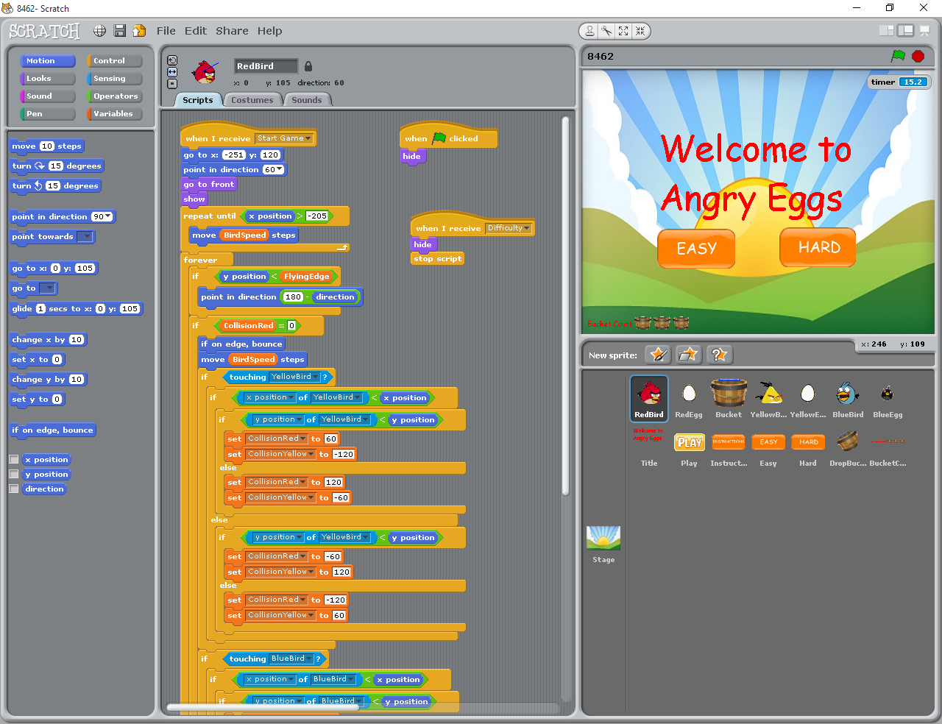
Figure 1. The Scratch graphic user interface. Scratch affords an accessible interface to achieve high-level complexity, event-driven applications.

Six sections of the course were co-taught by two instructors and two teaching assistants, at a large western Canadian University. Each section consisted of six hours of lectures/labs over a term of consisting of 13 consecutive weeks. The course was designed for pre-service teachers who did not have any previous programming or game design experience. A total of 166 students (106 male, 60 females) completed the course. A purposeful sample of 40 games was selected, consisting of an equal number of females and males. Each student was asked to indicate the range of hours they currently played digital games per week. Each game in the selected sample was evaluated against the GDAS, which took approximately 30 minutes per game.

Results

Participants indicated that they currently played between 1- 6 hours per week, with males indicating they played closer to 4-6 hours and females closer to 1-3 hours. However, there was no statistically significant differences on this measure between males and females (t(29)=1.767, p = 0.088). The correlation between the number of reported hours played per week and scores on the GDAS was not significant, indicating that the amount of current game playing students had only had a small association to their score on the GDAS (r= 0.197, n=31, p = 0.288).

The score on the GDAS was 13.35 (41.7%), with a standard deviation of 4.54 (14.2%). Although males’ average score (13.90) was slightly higher than females (12.80), there was no significant difference (t(38)=0.451, p = 0.451) between the two groups. Table 1 summarizes the descriptive results, showing the percentage scores for each of the criterion.
Table 1. Pre-service teachers’ scores on the individual criterion levels of the GDAS by percent.
 | Criteria | Points | Level | %
Problem Solving | Cognitive Objectives | 0 | No cognitive objectives present. | 5%
 |  | 1 | Offers simple cognitive objectives. | 85%
 |  | 2 | Offers complex cognitive objectives. | 10%
 | Forgiveness | 0 | Cost of failure is high. | 25%
 |  | 1 | Cost of failure is low. | 75%
 | Incremental Challenge | 0 | Challenges do not get harder as the game progresses. | 60%
 |  | 1 | Challenges do get harder as the game progresses. | 40%
Customization | Different Experiences | 0 | Multiple playthroughs yield the same experience. | 62.5%
 |  | 1 | Multiple playthroughs yield different experiences. | 37.5%
 | Player Choices | 0 | Player is not given chances to make choices. | 67.5%
 |  | 1 | Player can make minor choices affecting game. | 32.5%
 |  | 2 | Player is free to make a wide range of choices. | 0%
 | Customizable PC | 0 | The PC is not customizable. | 87.5%
 |  | 1 | The PC can be customized. | 12.5%
Player Interaction | NPC-NPC Interactions | 0 | No NPC interactions with other NPCs. | 92.5%
 |  | 1 | NPC interactions with other NPCs. | 7.5%
 | PC-NPC Interactions | 0 | No PC interactions with NPCs. | 32.5%
 |  | 1 | Interactions with NPCs are linear. | 52.5%
 |  | 2 | Interactions with NPCs change throughout the game. | 12.5%
 |  | 3 | PC actions affect NPCs reactions to the PC. | 2.5%
 | Reveal Information | 0 | No information is revealed to the player. | 60%
 |  | 1 | Information is told explicitly to the player. | 30%
 |  | 2 | Information is shown implicitly to the player. | 10%
 | Accessible Reference | 0 | No help reference is available. | 30%
 |  | 1 | References are available, but not consistently. | 62.5%
 |  | 2 | Player controls or other hints are accessible any time. | 7.5%
Atmosphere | Characters’ Animation | 0 | Characters are not animated. | 52.5%
 |  | 1 | PC is animated based on player actions (internal). | 30%
 |  | 2 | Environment and NPCs are animated (external). | 17.5%
 | Music, Sound, and Animation | 0 | Music, sound, and animation are absent. | 7.5%
 |  | 1 | One of the three is done well. | 20%
 |  | 2 | Two of the three are done well. | 37.5%
 |  | 3 | All three create a unified experience. | 35%
Player Motivation | Motivated Tasks | 0 | No high score functionality or storyline. | 40%
 |  | 1 | High score functionality included. | 27.5%
 |  | 2 | Storyline included. | 25%
 |  | 3 | Storyline is developed throughout the game. | 7.5%
 | Assumable Role | 0 | Players do not assume a role. | 55%
 |  | 1 | Players assume a role that is not developed. | 40%
 |  | 2 | Players take on or create a persona that is developed. | 5%
 | Achievements | 0 | No feedback upon completing achievement. | 90%
 |  | 1 | Player is not alerted upon achievement completion. | 2.5%
 |  | 2 | Player is alerted upon achievement completion. | 7.5%
 | Explicit Objectives | 0 | Objectives are NOT clear. | 30%
 |  | 1 | Objectives are clear. | 70%
Usability | Meaningful Feedback | 0 | The game does not provide feedback to the player. | 12.5%
 |  | 1 | The game provides feedback to the player. | 87.5%
 | Traditional Control Conventions | 0 | A traditional game control convention is not used. | 2.5%
 |  | 1 | A traditional game control convention is used. | 97.5%
 | Affordance and Visibility | 0 | Interactive objects are NOT clear. | 5%
 |  | 1 | Interactive objects are clear. | 95%

Discussion

The research in this paper investigates the degree to which pre-service teachers (with various amounts of game playing experience) were able to design and construct a digital game that incorporated key principles of learning associated with a good game. Their games were assessed using the GDAS which we developed to measure a core set of learning principles that are part of a ‘good digital game’ and which can promote fruitful and deep learning of content (Gee, 2007).

Pre-service teachers averaged between 1 to 6 gameplay hours per week. There was no significant relationship between the hours spent gaming per week and scores on the GDAS, as well as no significant differences between genders. These findings suggest that the amount of time pre-service teachers played digital games was not related to their ability to design and construct a good game. The low average score on the GDAS indicates that a pre-service teacher’s notion of what constitutes a good game design was weak. As a result, teacher educators should not assume that a student’s experience in game playing is indicative of their ability to design and construct a good game. More importantly, pre-service teachers may not be aware of the learning principles that are required to create a good game. This suggests that teacher educators who promote game design to enhance the learning of content material may need to structure pedagogical activities that specifically focus on how learning principles can support the design of a good digital game. It is our hope that teacher educators can use the GDAS as a starting point to assess digital games, and when suitable, modify the GDAS for their instructional context. What follows is a brief discussion of key categorical findings from Table 1.

Problem Solving Opportunities
Almost all (85%) of the pre-service teachers were not able to create games that incorporated more challenging cognitive objectives such as analyzing, synthesizing, and creating. Educators thinking of using game design may want address the challenge of incorporating higher-level cognitive tasks. That said, a majority of pre-service teachers did incorporate the important criteria ‘low cost of failure’ (forgiveness) and included features allowing for the player to build self-efficacy with game tasks. Furthermore, 40% of the games incorporated challenges that incrementally increased as the game progressed; this represented a game-based way of implementing Vygotsky’s (1978) concept of scaffolding.

Figure 2a shows a high-scoring game in this category similar to ‘Mastermind.’ It contained complex cognitive objectives to solve, featured multiple attempts allowing the player to make mistakes, though it did not become more difficult as the game progressed.

Customization of Player Experience
Few of the games that pre-service teachers created allowed for multiple playthroughs that yielded different experiences and none of the games allowed the player to make a wide range of choices while playing. Understanding that digital games creation can operationalize constructionist-learning principles, specifically differentiating for multiple perspectives, may help lend support for educators promoting digital game design in their teaching.

One of the more high-scoring games in this category was a Batman and Robin ‘beat-‘em-up arcade’-style game had randomized elements throughout the game featuring different adversary behaviour on different playthroughs, and allowed the player to choose whether to play as Batman or Robin (see Figure 2.b).

Player Interaction
Whitton (2014) states that interactivity and feedback are central learning constructs that help define a good game. Without meaningful feedback, players are unable to correct previously incorrect behaviours in the game. Results for the inclusion of interaction criteria were unexpectedly low. Given these pre-service teachers were in the third or fourth year of their program, our expectation was that the learning constructs of interactivity and feedback would transfer into their game design experience.

A dungeon fighter simulator scored high in this category by allowing the player to take control of a party of fantasy warriors to defeat a monster. Every player-controlled party member had different offensive and defensive capabilities. While the game only featured one NPC, the game showed the player what kind of effects different actions would have, and an extensive help menu was available throughout the game (see Figure 2c).

Game Atmosphere
A majority of the pre-service teachers (over 70%) recognized that music and sound are important components to creating a digital game. This finding was encouraging and somewhat expected given that most current games emphasize game atmospheres that are rich in visual music and sounds.

One of the more high-scoring games in this category was an American style football mini-game collection. This game featured player and object animations, character sounds, and game music that as a package was very reminiscent of a professionally packaged arcade game (see Figure 2d).

Player Motivation
Gee (2006) indicated that digital games presented in story form are an excellent way to motivate and engage users because “[h]umans find story elements profoundly meaningful and are at a loss when they cannot see the world in terms of such elements” (p. 2). Although the number of games that included a narrative or featured players adopting a role was low, it was encouraging to see cases where this was done well.
An example of a game that scored high in this category was an extremely detailed role playing game. This game contained a well-developed story, had the player don a role that was developed throughout the game, contained achievements for the player to accomplish with feedback upon achievement completion, and was explicit in letting the player know what to achieve next (see Figure 2e).

Interface Usability
In general, pre-service teachers were very clear on what constituted good interface design and it was encouraging to see that the overwhelming majority incorporated meaningful feedback into the interfaces and used consistent control conventions based on industry standards.
One example featured birds dropping eggs that the player needed to catch in a basket they moved by using the arrow keys. The player’s score would change based on the type of egg caught in the basket. In addition to having explicit instructions at the beginning of the game, the form of the basket informs the player that they should collect objects inside of it (see Figure 2f).

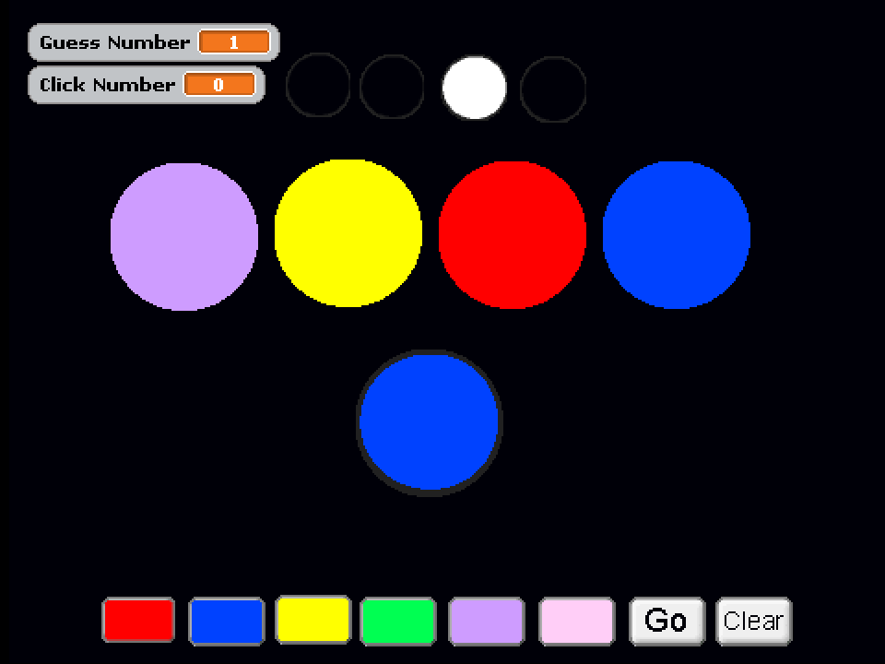  2a. Problem Solving  Opportunities | 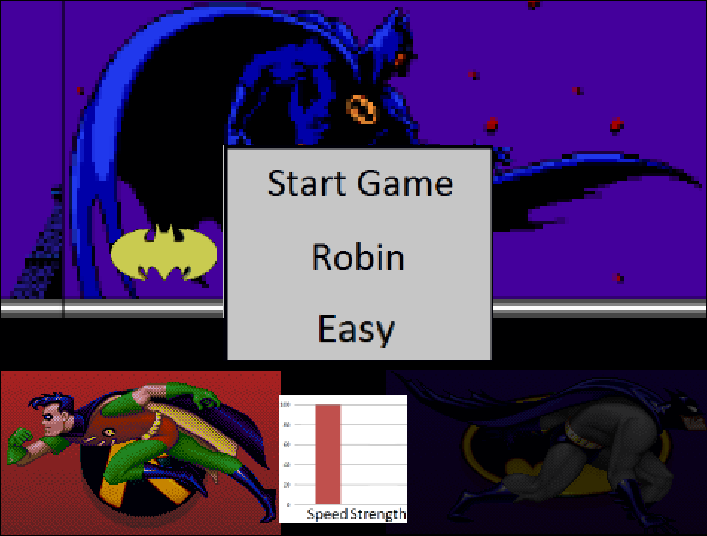  2b. Customization of Player  Experience | 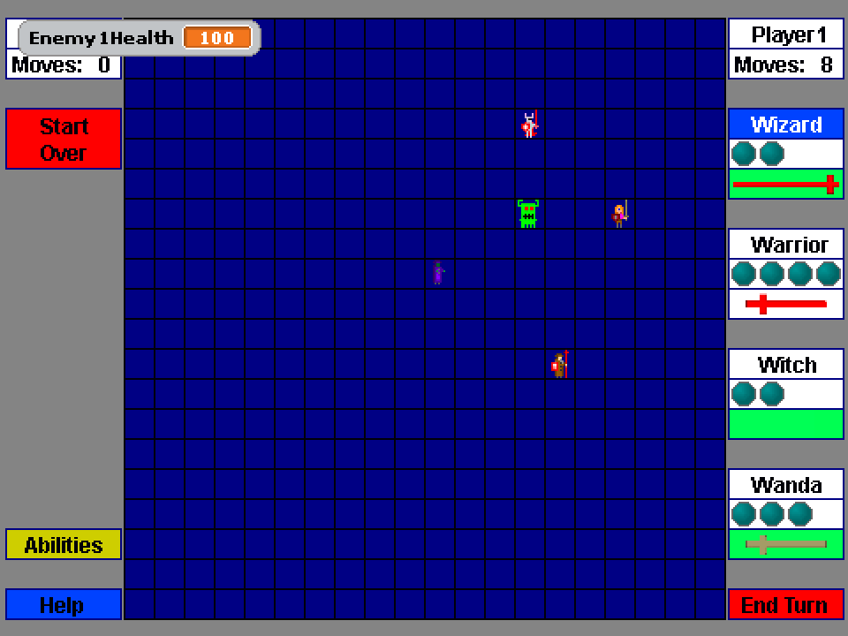  2c. Player Interaction
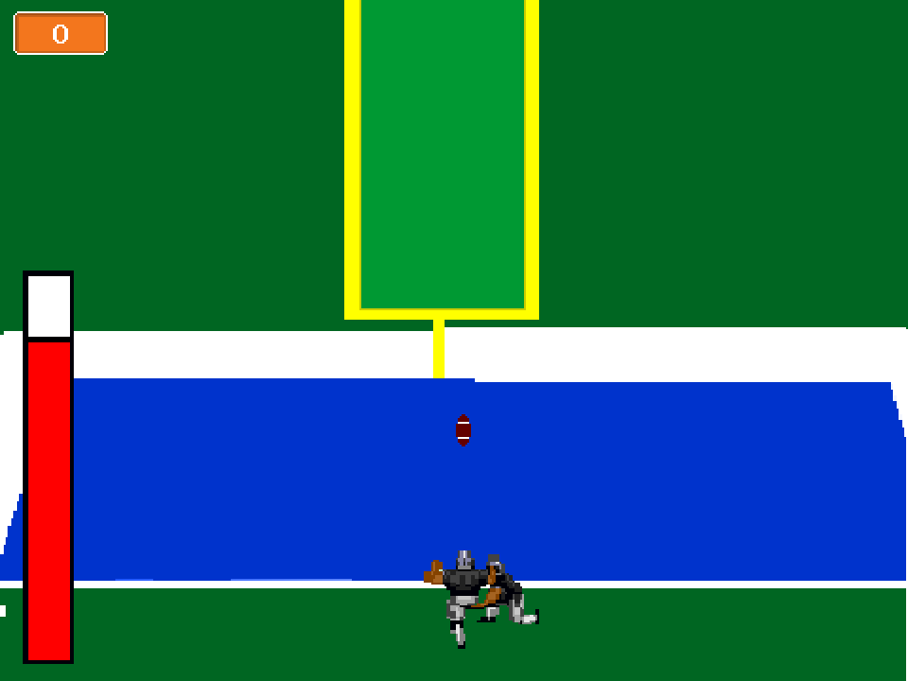  2d. Game Atmosphere | 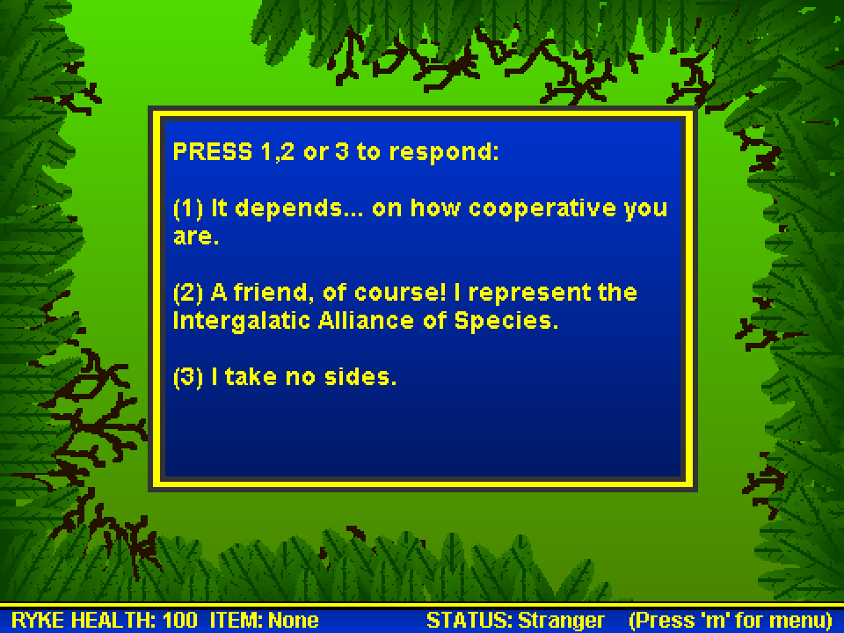  2e. Player Motivation | 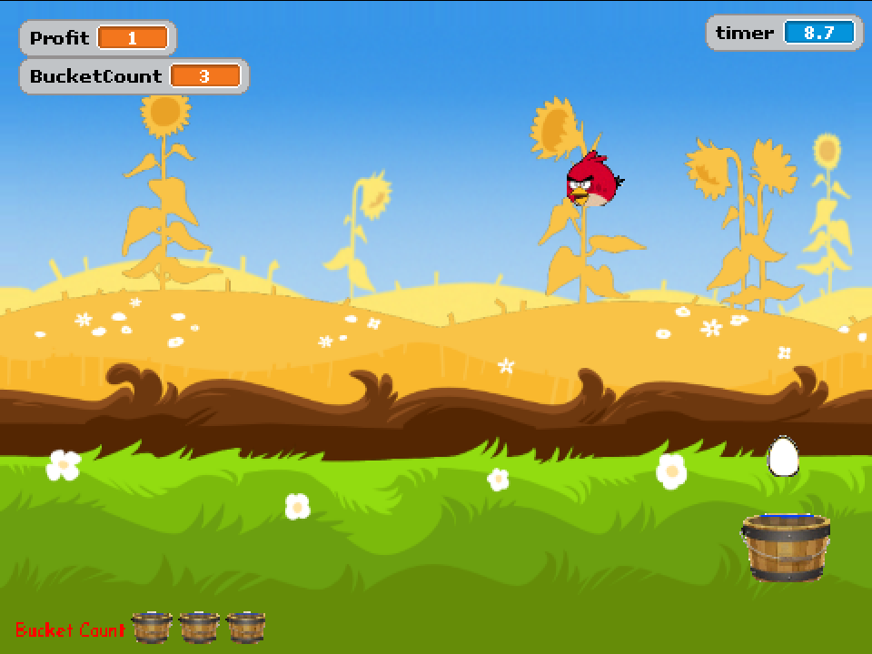  2f. Interface Usability
Figure 2(a-f). Examples of high-scoring Scratch games from different categories.

Limitations

Our study has a number of limitations that could be addressed in future research. The GDAS is the first instrument we are aware of that formally evaluates digital games designed and constructed by pre-service teachers in Scratch. As such, the authors are aware that issues of instrument validity and reliability are ongoing. The application of the GDAS in this study should therefore be considered a pilot implementation and results should be interpreted within the limitations of the instrument’s maturity and the context in which it was applied. It is our hope that others would adopt, modify, and evolve the GDAS for application in their specific educational situation.

The participants in this study are also limited to the context of the teacher education program from which they were drawn. Furthermore, while our sample group consisted of both pre-service teachers in an elementary and secondary traditional four-year undergraduate teacher programs, this sample was based on those students who selected this educational technology course as an education course elective (based on interest).

Conclusion

If pre-service teachers wish to use digital games design and construction in their future classrooms, they need to develop an understanding of how to incorporate principles of learning into game design. While engaging their students in a game building experience, teachers should remind them to include numerous choices for players, multiple ways of interacting, and a storyline to engage their audience, as these are the elements that teachers were found to have missed most frequently while designing and building their own games. Gee’s learning principles for digital games appears to be a viable foundation for the creation of a game rubric such as the Game Design Assessment Survey (GDAS).

References

Bandura, A. (1994). Efficacy. Behaviour Therapist, 17, 127-127.

Bickford, P. (1997). Interface design: the art of developing easy-to-use software. Academic Press.

Bloom, B. S. (1956). Taxonomy of educational objectives. Vol. 1: Cognitive domain. New York: McKay.

Brand, J. E. & Todhunter, S. (2015). Digital Australia 2016. Eveleigh, NSW: IGEA. Retrieved from http://www.igea.net/wp-content/uploads/2015/07/Digital-Australia-2016-DA16-Final.pdf

Brown, H. J. (2014). Videogames, history, and education. In Videogames and education (117-135). London: Routledge.

Carbonaro, M., Cutumisu, M., Duff, H., Gillis, S., Onuczko, C., Siegel, J., ... & Waugh, K. (2008). Interactive story authoring: A viable form of creative expression for the classroom. Computers & Education, 51(2), 687-707.

Carbonaro, M., Szafron, D., Cutumisu, M., & Schaeffer, J. (2010). Computer-game construction: A gender-neutral attractor to Computing Science. Computers & Education, 55(3), 1098-1111.

Clark, D. B., Tanner-Smith, E. E., & Killingsworth, S. S. (2015). Digital Games, Design, and Learning A Systematic Review and Meta-Analysis. Review of educational research, 0034654315582065.

Crawford, C. (1982). A taxonomy of computer games. The Art of Computer Game Design. New York: McGraw-Hill Osborne Media.

Csikszentmihalyi, M. (1990). Flow: The Psychology of Optimal Experience. New York: Harper and Row.

Cutumisu, M., & Szafron, D. (2009). An Architecture for Game Behavior AI: Behavior Multi-Queues. In AIIDE.

Cutumisu, M., Szafron, D., Schaeffer, J., McNaughton, M., Roy, T., Onuczko, C., & Carbonaro, M. (2006). Generating ambient behaviors in computer role-playing games. Intelligent Systems, IEEE, 21(5), 19-27.

Cydis, S. (2015). Authentic instruction and technology literacy. Journal of Learning Design, 8(1), 68-78.

Denner, J., Werner, L., & Ortiz, E. (2011). Computer games created by middle school girls: Can they be used to measure understanding of computer science concepts? Computers & Education, 58(1), 240-249. doi: 10.1016/j.compedu.2011.08.006

Dickey, M. D. (2005). Engaging by design: How engagement strategies in popular computer and video games can inform instructional design. Educational Technology Research and Development, 53(2), 67–83. doi:10.1007/bf02504866

Entertainment Software Association (ESA). (2012). Essential facts 2012. Report. Retrieved from http://theesa.ca/wp-content/uploads/2015/08/Essential-Facts-2012-EN.pdf

Gee, J.P. (2003). What video games have to teach us about learning and literacy. New York, NY: Palgrave Macmillan. doi:10.1145/950566.950595

Gee, J.P. (2005). Good video games and good learning. In Phi Kappa Phi Forum (Vol. 85, No. 2, p. 33). THE HONOR SOCIETY OF PHI KAPPA PHI. Retrieved from http://www.phikappaphi.org/publications-resources/

Gee, J.P. (2006). Why game studies now? Video games: A new art form. Games and culture, 1(1), 58-61. Retrieved from http://www.jamespaulgee.com/sites/default/files/pub/GamesCulture-1-1.pdf

Gee, J.P. (2007). Good video games + good learning: Collected essays on video games, learning, and literacy. New York: P. Lang.

Gee, J.P. (2013). Video games and learning [Video file].

Gee, J.P. (2014). What video games have to teach us about learning and literacy. Macmillan.

Good, J. (2011). Learners at the wheel: Novice programming environments come of age. International Journal of People-Oriented Programming (IJPOP), 1(1), 1-24. doi: 10.4018/ijpop.2011010101

Groff, J., Howells, C., & Cranmer, S. (2010). The impact of console games in the classroom: Evidence from schools in Scotland. UK: Futurelab.

Herrington, J., Reeves, T. C., & Oliver, R. (2014). Authentic learning environments (pp. 401-412). Springer New York.

Hsu, T. Y., & Chiou, G. F. (2014, June). A Play-Design-Programming Model for the Training of Preservice Teachers’ Education Game Literacy. In World Conference on Educational Multimedia, Hypermedia and Telecommunication (Vol. 2014, No. 1, pp. 1887-1891).

Huitzinga, J. (1944). Homo Ludens: A study of the play element in culture. Routledge and Kegan Paul.

Jennett, C., Cox, A. L., Cairns, P., Dhoparee, S., Epps, A., Tijs, T., & Walton, A. (2008). Measuring and defining the experience of immersion in games. International journal of human-computer studies, 66(9), 641-661.

Koehler, M. J., & Mishra, P. (2005). Teachers learning technology by design. Journal of Computing in Teacher Education, 21(3), 94-102.

Klopfer, E., Osterweil, S., & Salen, K. (2009). Moving learning games forward. Cambridge, MA: The Education Arcade.

Koster, R. (2005). A theory of fun for game design. Paraglyph Press.

Latham, G., & Carr, N. (2012). Authentic Learning for Pre-Service Teachers in a Technology-Rich Environment. Journal of Learning Design, 5(1), 32-42.

Li, Q. (2013). Digital games and learning: A study of preservice teachers' perceptions. International Journal of Play, 2(2), 101-116.

Lombard, M., Reich, R. D., Grabe, M. E., Bracken, C. C., & Ditton, T. B. (2000). Presence and television. Human Communication Research, 26(1), 75-98.

Malone, T. W. (1982, March). Heuristics for designing enjoyable user interfaces: Lessons from computer games. In Proceedings of the 1982 conference on Human factors in computing systems (pp. 63-68). ACM.

Mayer, R. E. (2011). Multimedia learning and games. In S. Tobias & J.D. Fletcher (eds.), Computer games and instruction (p. 281-305). Charlotte, NC: Information Age Publishing, Inc. doi:10.1017/cbo9781139547369.037

Metacritic. (2015). Metacritic. Retrieved October 21, 2014 from http://www.metacritic.com/browse/games/score/metascore/all/all

MIT. (2009). Scratch (Version 1.4) [computer software]. Available from http://scratch.mit.edu/

Murphy, C., Chertoff, D., Guerrero, M., & Moffitt, K. (2013). Design better games! Flow, motivation, & fun. In S. Coleman & T. Hussain (Eds.), Design and development of training games: practical guidelines from a multi-disciplinary perspective (146-178). Cambridge: Cambridge University Press.

Newmann, F. M., & Wehlage, G. G. (1993). Five standards of authentic instruction. Educational leadership, 50(7), 8-12.

Nielsen, J. (1994, April). Enhancing the explanatory power of usability heuristics. In Proceedings of the SIGCHI conference on Human Factors in Computing Systems (152-158). ACM.

Norman, D. A. (2002). The design of everyday things. Basic books.

Oxland, K. (2004). Gameplay and design. Pearson Education.

Papert, S. (1991). Situating Constructionism. In I. Harel & S. Papert (Eds.), Constructionism (pp. 5-23). Norwood, NJ:Ablex.

Prensky, M. (2008). Students as designers and creators of educational computer games: Who else? British Journal of Educational Technology, 39(6), 1004-1019.

Rickard, N. S. (2004). Intense emotional responses to music: a test of the physiological arousal hypothesis. Psychology of Music, 32(4), 371-388.

Robertson, J., & Howells, C. (2008). Computer game design: Opportunities for successful learning. Computers & Education, 50(2), 559-578.

Schrader, P. G., Archambault, L. M., & Oh-Young, C. (2011). Training by Gaming: Preparing Teachers of Today for Tomorrow’s Learning Environments. Journal of Technology and Teacher Education, 19(3), 261-286.

Vos, N., van der Meijden, H., & Denessen, E. (2011). Effects of constructing versus playing an educational game on student motivation and deep learning strategy use. Computers & Education, 56(1), 127-137. doi: 10.1016/j.compedu.2010.08.013

Vygotsky, L. (1978). Interaction between learning and development. Readings on the development of children, 23(3), 34-41.

Whitton, N. (2014). Digital Games and Learning: Research and Theory. London, UK: Routledge. doi:10.4324/9780203095935

Appendix

Game Design Assessment Survey (GDAS)

Problem Solving Opportunities (0-4)
Game contains cognitive objectives (0-2)
 | 0 Points | No cognitive objectives present.
 | 1 Point | Offers simple cognitive objectives. I.e. remembering, understanding, or applying.
 | 2 Points | Has complex cognitive objectives requiring effort to solve. I.e. analyzing, evaluating, or creating.
Forgiveness (0-1)
 | 0 Points | Cost of failure is high (no checkpoints or lives system are implemented; player must restart).
 | 1 Point | Cost of failure is low (a system exists so the player does not need to start from the beginning).
Challenge incrementally increases as the game progresses (0-1)
E.g., antagonists get faster or stronger as the game progresses.
 | 0 Points | Levels do not get harder, antagonists do not get faster or stronger, etc. as the game progresses.
 | 1 Point | Levels get harder, antagonists get faster or stronger, etc. as the game progresses.

Customization of Player Experience (0-4)
Multiple playthroughs yield different experiences (0-1)
 | 0 Points | Multiple playthroughs yield the same experience.
 | 1 Point | Multiple playthroughs yield different experiences.
Allows multiple ways through the game based on player choices (0-2)
 | 0 Points | Player is not given opportunities to make choices throughout the game. I.e., linear game.
 | 1 Point | Player can make minor choices affecting game. I.e., choosing a path right or left path, picking up different items throughout the game.
 | 2 Points | Player is free to make a wide range of choices. I.e., synthesizing a variety of items in Minecraft.
Players can customize the PC¹ (0-1)
 | 0 Points | The PC is not customizable.
 | 1 Point | The PC can be customized.

Player Interaction (0-8)
NPC² interactions with other NPCs (0-1)
 | 0 Points | No NPC interactions with other NPCs.
 | 1 Point | NPC interactions with other NPCs.
Player interactions with NPCs (0-3)
 | 0 Points | No PC interactions with NPCs.
 | 1 Point | Interactions with NPCs are linear and scripted throughout the game. E.g., NPCs may repeat the same line over and over again.
 | 2 Points | Interactions with NPCs change throughout the game. E.g., can change throughout story completion, can randomly be selected to display at a time.
 | 3 Points | PC actions affect NPCs reactions to the PC. E.g., PC eliminates a family member of the NPC and can no longer interact friendly with that character, PC completes a quest for the NPC making the NPC trust the PC with further tasks.
Information is revealed as the player needs it (0-2)
 | 0 Points | No information is revealed to the player.
 | 1 Point | Information is told explicitly to the player. E.g., in God of War, the player presses buttons at certain times during reaction events.
 | 2 Points | Information is shown implicitly to the player. E.g., in Mega Man, some obstacles or enemy behaviours appear before the player encounters them so they can deduce a proper action to take when they encounter that obstacle or enemy.
A reference can be looked at if the user desires (0-2)
 | 0 Points | No help reference is available.
 | 1 Point | Player controls or other hints are shown sometime in the game, but are not accessible over the course of the game. E.g., Controls are displayed at the beginning
 | 2 Points | Player controls or other hints are accessible over the course of the game.

Game Atmosphere (0-5)
Characters’ animation (0-2)
 | 0 Points | Characters are not animated.
 | 1 Point | PC is animated based on player actions (internal). E.g., when buttons are pressed, player’s death (reaction).
 | 2 Points | Environment and NPCs are animated (external). E.g., NPC’s reaction to player’s attacks.
Music, sound, and animation (0-3)
 | 0 Points | Music, sound, and animation are absent from the game.
 | 1 Point | One of Music, sound XOR animation is extremely well done.
 | 2 Points | Two of music, sound, and animation are unified.
 | 3 Points | Music, sound, animation, and tasks all create a unified experience.

Player Motivation (0-8)
Player is motivated to complete tasks given to PC (0-3)
 | 0 Points | No high score functionality or storyline.
 | 1 Point | High score functionality included.
 | 2 Points | Storyline included.
 | 3 Points | Storyline is developed throughout the game and has an ending.
Users assume a role in the game, rather than simply playing (0-2)
 | 0 Points | Players do not take on or create a persona that they develop throughout the game.
 | 1 Point | Players take on or create a persona that is not developed throughout the game.
 | 2 Point | Players take on or create a persona that is developed throughout the game.
Achievements present in the game (0-2)
 | 0 Points | No immediate, meaningful feedback is given to the player upon accomplishing optional tasks in the game.
 | 1 Point | Achievements are present, but the player isn't alerted when these are accomplished.
 | 2 Points | Immediate, meaningful feedback is given to the player upon accomplishing additional tasks in the game.
Rules, goals and objectives are explicit (0-1)
 | 0 Points | The rules, goals, and objectives the player must complete are NOT explicit; the player does NOT know what they must accomplish.
 | 1 Point | The rules, goals, and objectives the player must complete are explicit; the player knows what they must accomplish.

Interface Usability (0-3)
Meaningful feedback (0-1)
 | 0 Points | The game does not provide feedback to the player when there is a change of state.
 | 1 Point | The game provides feedback to the player when there is a change of state.
Uses traditional control conventions (0-1)
 | 0 Points | When appropriate to use an existing control scheme, this is ignored and a traditional game control convention is not used.
 | 1 Point | If appropriate, traditional game control conventions are used.
Affordance and visibility (0-1)
 | 0 Points | Objects that the player needs to interact with are NOT salient or it is not obvious with what or how the player should interact with objects.
 | 1 Point | Objects the player needs to interact with are salient and it is obvious with what or how the player should interact with objects.

Notes. ¹ PC refers to the Player Character in a game.
² NPC refers to the Non-Player Character(s) in a game.

